

**Phase 4**

*Final Report*

*Intersection Safe*

*A Report*

*Presented to*

*The Department of Electrical & Computer Engineering*

*Concordia University*

*In Partial Fulfillment*

*of the Requirements*

*of ELEC/COEN490*

*By:*

*Team 11*

*Mohammed Al-Taie ID: 40097284*

*Paul Westenberg ID: 40087074*

*Erfan Reza ID: 40080730*

*Saro Nokhoudian ID: 40073669*

*Rifadul Haque ID: 40107346*

*Jean Mardini ID: 40031904*

*Project Supervisor*

*Dr. Hashtrudi Zad*

Wednesday, March 28th 2023

# ABSTRACT

Have you ever been in a car collision? If so, we can almost guarantee that this happened at an intersection. In fact, over 50% of car accidents happen at intersections. Every year, the Federal Highway Administration (FHA) reports approximately 2.5 million intersection accidents in the US. Our device aims to reduce this number.

IntersectionSafe is a device that uses modern technology in order to prevent intersection collisions from happening. It will do so by calculating the speed of vehicles approaching an intersection and determining if they are able to stop in time for the red/yellow light. If the system determines they can’t, it will send an alarm to perpendicular traffic in order to warn the surrounding vehicles, cyclists and pedestrians of this infringement, ordering them to stop and not cross the intersection in the hopes of preventing the accident. IntersectionSafe will also act as a data collection device, in order to create an optimized green to red light ratio at intersections. It will do so by counting the cars per hour in both directions and modifying the traffic lights accordingly.

# INTRODUCTION AND OBJECTIVES

About half of the collisions in urban areas and 30% of collisions in rural areas are intersection collisions. This is often due to inattention from drivers to an excessive amount of traffic or to people trying to catch that last second yellow light. Our product, IntersectionSafe, aims to reduce these numbers and improve the safety of drivers everywhere.

IntersectionSafe is an Intersection Side-Impact Collision Alert System. It is a system put in place at an intersection that alerts drivers when there is a possibility of a collision. It monitors the flow of traffic and detects whether a vehicle is approaching a red or yellow light at a fast pace. The speed of the car indicates that it will not have time to stop before the light, so it alerts the perpendicular vehicles of this. Furthermore, IntersectionSafe will act as an AI and data collection device in order maximize the efficiency of lights and therefore, traffic in general. The data collection is further enhanced and demonstrated using an app which shows the number of cars passed by the intersection every hour.

The objective of this capstone project is to design and implement the electrical and computer system for IntersectionSafe. This will be done by a collaboration of 2 electrical engineers and 4 computer engineers.  Our goal is to reduce intersection collisions, save lives and optimize traffic using a simple, yet efficient system called IntersectionSafe. This report outlines the entirety of our journey in the construction of IntersectionSafe, giving a complete and thorough guide on its production and design process.

In this report we will demonstrate the requirements of the project. After the specification of the requirements there have been some calculations that demonstrate the engineering details that need to be respected throughout the project. Furthermore, the report will demonstrate the general design review followed by the schematic diagram. After gathering all of this information, finally it will be the time to have alternative solutions. After comparing and analyzing each alternative, the report will show the final decisions and move on to design development. Design development will demonstrate the hardware, electrical and software designs of the project. Lastly, the report will show the final budget and the test plan of the final project.

**DESCRIPTION OF THE PROJECT**

# REVIEW OF DESIGN SPECIFICATION

Below are the steps explaining how our product will work and prevent intersection collisions.

1. **The Speeding Vehicle** is a vehicle going above 40 km/h on a 40 km/h speed limit approaching and unable to stop before the red/yellow light.
2. **The Sensor Module** (camera) shall analyze the incoming traffic, which consists in the number of vehicles approaching, as well as their speeds.
3. **The Detection Module** (processor) will receive the information from the sensor module and determine if the vehicles are considered risks to the intersection.
4. **The Alerting Module** alerts the perpendicular drivers immediately. It will use a light as well as a siren for pedestrians and bikers.
5. **The Data Collection & Interpretation Module** uses the sensor module to collect information on how many vehicles have gone by and send the information to a database.

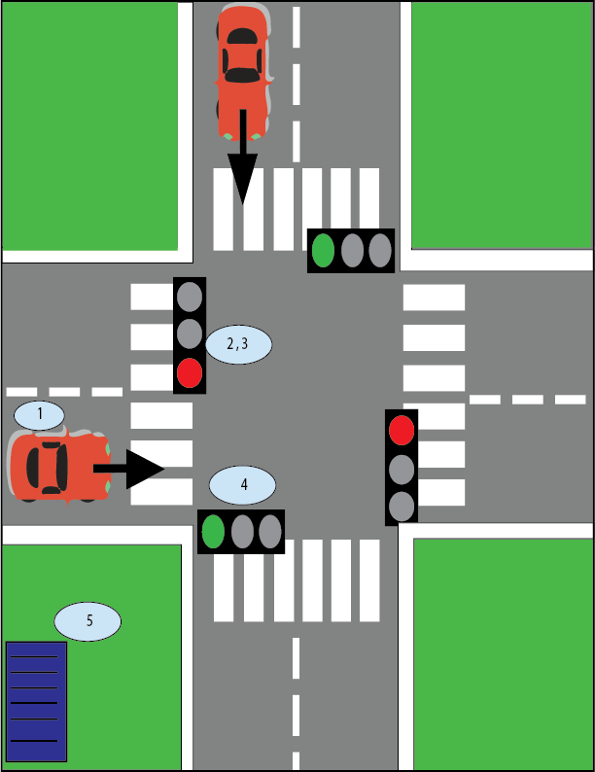

*Figure 1: Birds Eye view of the intersection with the approximate locations of all components*

In this section, we go over each component that will be used in the creation of IntersectionSafe and specify its requirements. The following table represents each of the different modules present in our device, along with the requirements and objectives we have placed for that particular module. This table will guide us in determining which products to choose in our design as all specifications must be met for each module.

Note: The superscript number next to values has been determined through calculations. These can be found in the next section entitled ‘**Calculations’** with the according to number superscript.

*Table 1: Requirements*

| **ID** | **Requirement** |
| --- | --- |
| **1** | **Vehicle** |
| 1.1 | The vehicle(s) our system will detect will be standard passenger cars. The system will not detect buses, motorcycles, bicycles, ambulances or limousines. |
| 1.2 | The cars our system will detect will be ± 20% of an average-car length (width of 1.76 m and height of 1.52 m), meaning it will detect between a width of 1.45 m and 2.12 m and between a height of 1.22 m and 1.83 m. |
| **2** | **Intersection** |
| 2.1 | The system shall detect vehicles at a + shaped 4-way intersection all containing traffic lights. Bike lanes will not be present at this intersection. |
| 2.2 | The system shall detect vehicles at a 2 lane per road intersection. This means each side of the intersection will have 4 lanes, 2 going one way and 2 going the other. |
| 2.3 | The lanes will be Quebec standard lane size measuring 3 metres. This means our system will be able to detect ± 20% of the lane, between 2.4 and 3.6 metres. |
| 2.4 | The speed limit on all sides of the intersection will be 50 km/h. |
| **3** | **Device** |
| 3.1 | The device shall be able to detect the speed of vehicles approaching the intersection within a range of 20 to 80 km/h |
| 3.2 | The device shall aim at 34.7m1 from the intersection in order to give the perpendicular vehicles 2 seconds to break in time |
| 3.3 | The device shall detect the speed of the incoming vehicles with a maximum delay of 0.5 seconds2. |
| **4** | **System** |
| 4.1 | The system shall be able to send the alert and display the alert with a maximum delay of 1 second3 upon reception of the speed. |
| 4.2 | The system shall alert the perpendicular traffic using a bright light. The light specifications are stated below. |
| 4.3 | The system shall record the information on the speed of the vehicles as well as the number of cars and send it to a server. There is no time constraint on this as it is not urgent. |

*Table 2: Non-Functional Requirements*

| ID | Requirements |
| --- | --- |
| **1** | **General** |
| 1.1 | The system shall be powered by the intersections pole power outlet |
| 1.2 | The communication wire shall pass from Detection Module to Alert Module inside the intersections pole |
| **2** | **Environment** |
| 2.1 | The device shall be designed in order to reduce the probability of collisions |
| 2.2 | The device shall be designed to reduce traffic and thus benefiting the environment |
| 2.3 | The device shall be able to  operate in temperatures from -10 to 30 degree Celsius |
| **3** | **Future Development** |
| 3.1 | The device will implement its Automatic Emergency Braking (AEB) |
| 3.2 | The alert system can connect to self-driving vehicles and automatically breaks in the case of an emergency. |

# Calculations:

## 1: Choosing 10 to 60m for detecting speed distance

We chose a range of 10 to 60 m so that we have enough time to detect the car and do the calculation for accelerating and decelerating vehicles. A breakdown for our selection:

We detect the car at 60 m away from the incoming traffic light. We process the speed and time every 5m. At 50 m we check if the car is accelerating or decelerating, if the car is accelerating, we check it again at 40m and 35 m and so on and depending on that we can send the alert starting from 30m or at the following distance. We can also start the alarm anytime in between, for instance if the car is at 80km/h on a 50 km/h road while being 50m away we can start the alarm at 40m. We chose 10m to be the starting range as we want to be sure for the cars that are going at the speed limit as we do not want any false alarm.

Below is the distance that is required for a car depending on the speed:

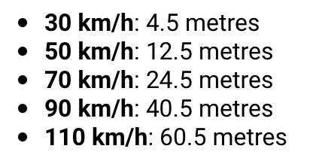

## 2: Width Minimum Angle

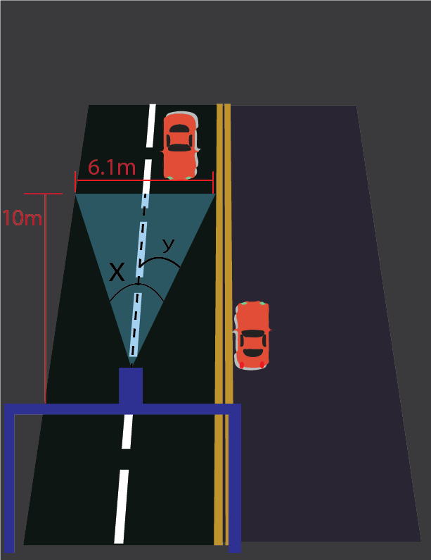

*Figure 2: Width Minimum Angle Visualized*

Figure 2 above helps us to determine the minimum angle width our camera will have. Using tan function, we have:

angle y: tan(y) = 3.05/10 -> y = tan-1(3.05/10) = 16.96 degrees

angle x = y * 2 = 33.92 degrees.

Thus, our minimum angle camera width required is 33.92 degrees.

## 3: Height Minimum Angle

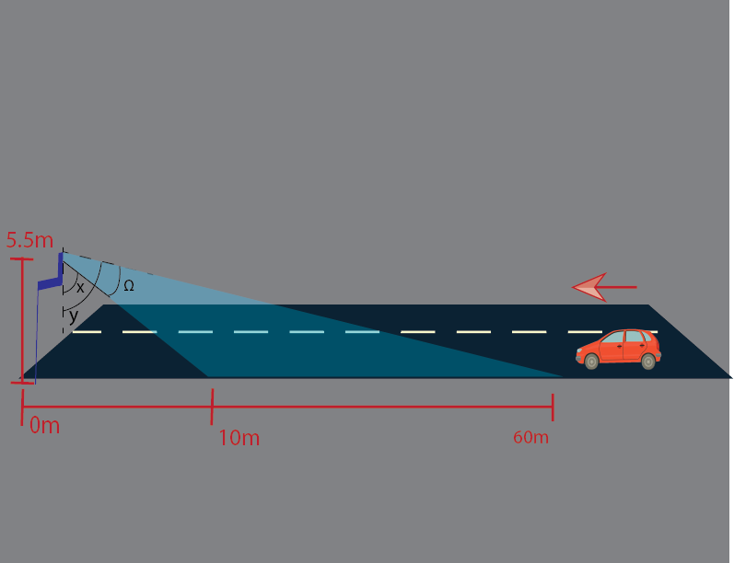

*Figure 3: Height Minimum Angle Visualized*

Figure 3 above helps us to determine the minimum angle height our camera will have. Using sin function, we have:

angle x : tan(x) = 10/5.5 -> x = tan-1(10/5.5) = 61.19 degrees

angle y : tan(y) = 60/5.5 -> y = tan-1(60/5.5) = 84.76 degrees

angle Ω : Ω = y-x = 84.76 - 61.19 = 23.57 degrees.

Thus, our minimum angle camera height required is 23.57 degrees.

## 4: Choosing Resolution

Minimum resolution needed is: 1280x720 pixels with 120fps

1280x720 pixels with 120 fps need → 8 Mbps

## 5: Minimum Distance Required

From figure 2.2, using Pythagoras’s theorem,

MinimumDistance^2 = 60^2 + 5.5^2 = 3630.25

MinimumDistance = sqrt(3630.25) = 60.25m

Thus, the camera shall be able to capture a distance of at least 60.25 metres

## 6: Obtaining Minimum Memory Required

for CPU:

This is the CPU speed that we have. (it will run the operating system and so on…)

for CPU: 1.5*10^9*64 = 9.610^10 bps --> for bytes per second : 9.610^10 /8 = 1.2*10^10 Bps = 12GBps

The minimum requirement to run the openCV library is 1.9 GB of Ram. since the processing time is crucial in our project then we assume we will need at least twice the size of the minimum requirement which will be 3.8 GB of RAM almost equal to 4 GB of Ram. [1]

1.9GB RAM minimum requirement for openCV library [2]

## 7: Obtaining Minimum Processing Speed of Processor

Minimum frequency required to run openCV library is 700MHz. However, the processing time is very crucial in our project. Therefore, we will need at least two times of the minimum requirement which will be 1.4 Ghz.

## 8: input requirement for the alerting module

As ITE standards, it should operate 60 ± 3 cycle ac line power over voltage range from 80 to 135 Vac rms.

## 9: Obtain the minimum and maximum maintained luminous intensity of the signal light

From the ITE requirement table, we can see that the maximum luminous intensity for yellow LED signal modules is acceptable at 617 cd. However, to calculate the minimum we should take the 80% of the average of candela values of the yellow led lights which will give 288 cd. [3]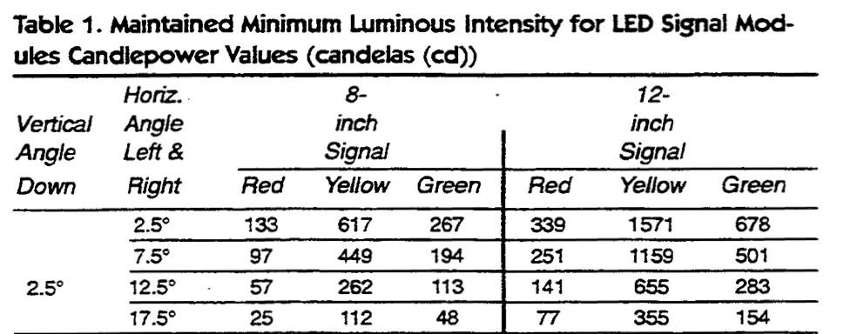

Thus, 617 cd have 33.75% of uncomfortable percentage and 288 cd have 15.75% respectively.

The general values to calculate uncomfortable for yellow lights percentages are:

10% → 8413 cd/m2→ 264 cd

25 % → 14557 cd/m2 → 457 cd

## 10: The entire device input power

As Quebec power lines provide 120V ac with 60 Hz of frequency then our entire device should have one input of these values.

# DESIGN REVIEW

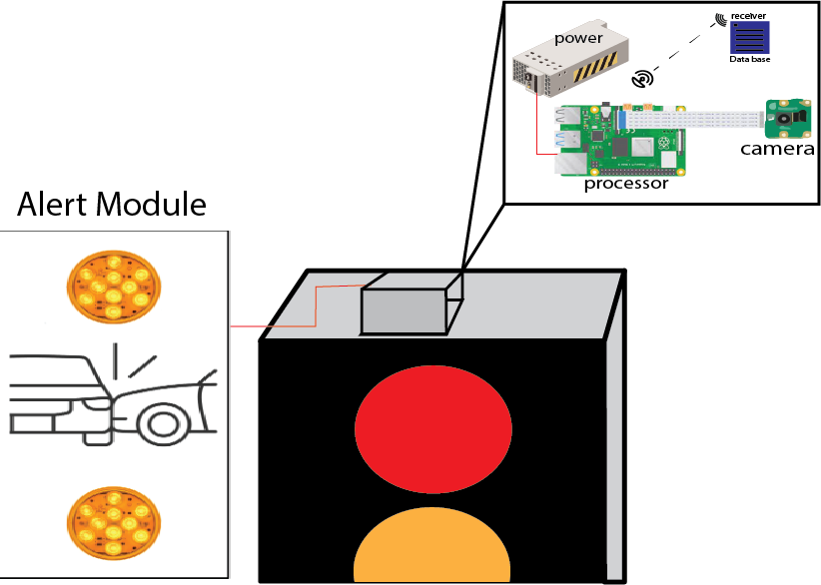

*Figure 11: General Positioning of Components in Environment*

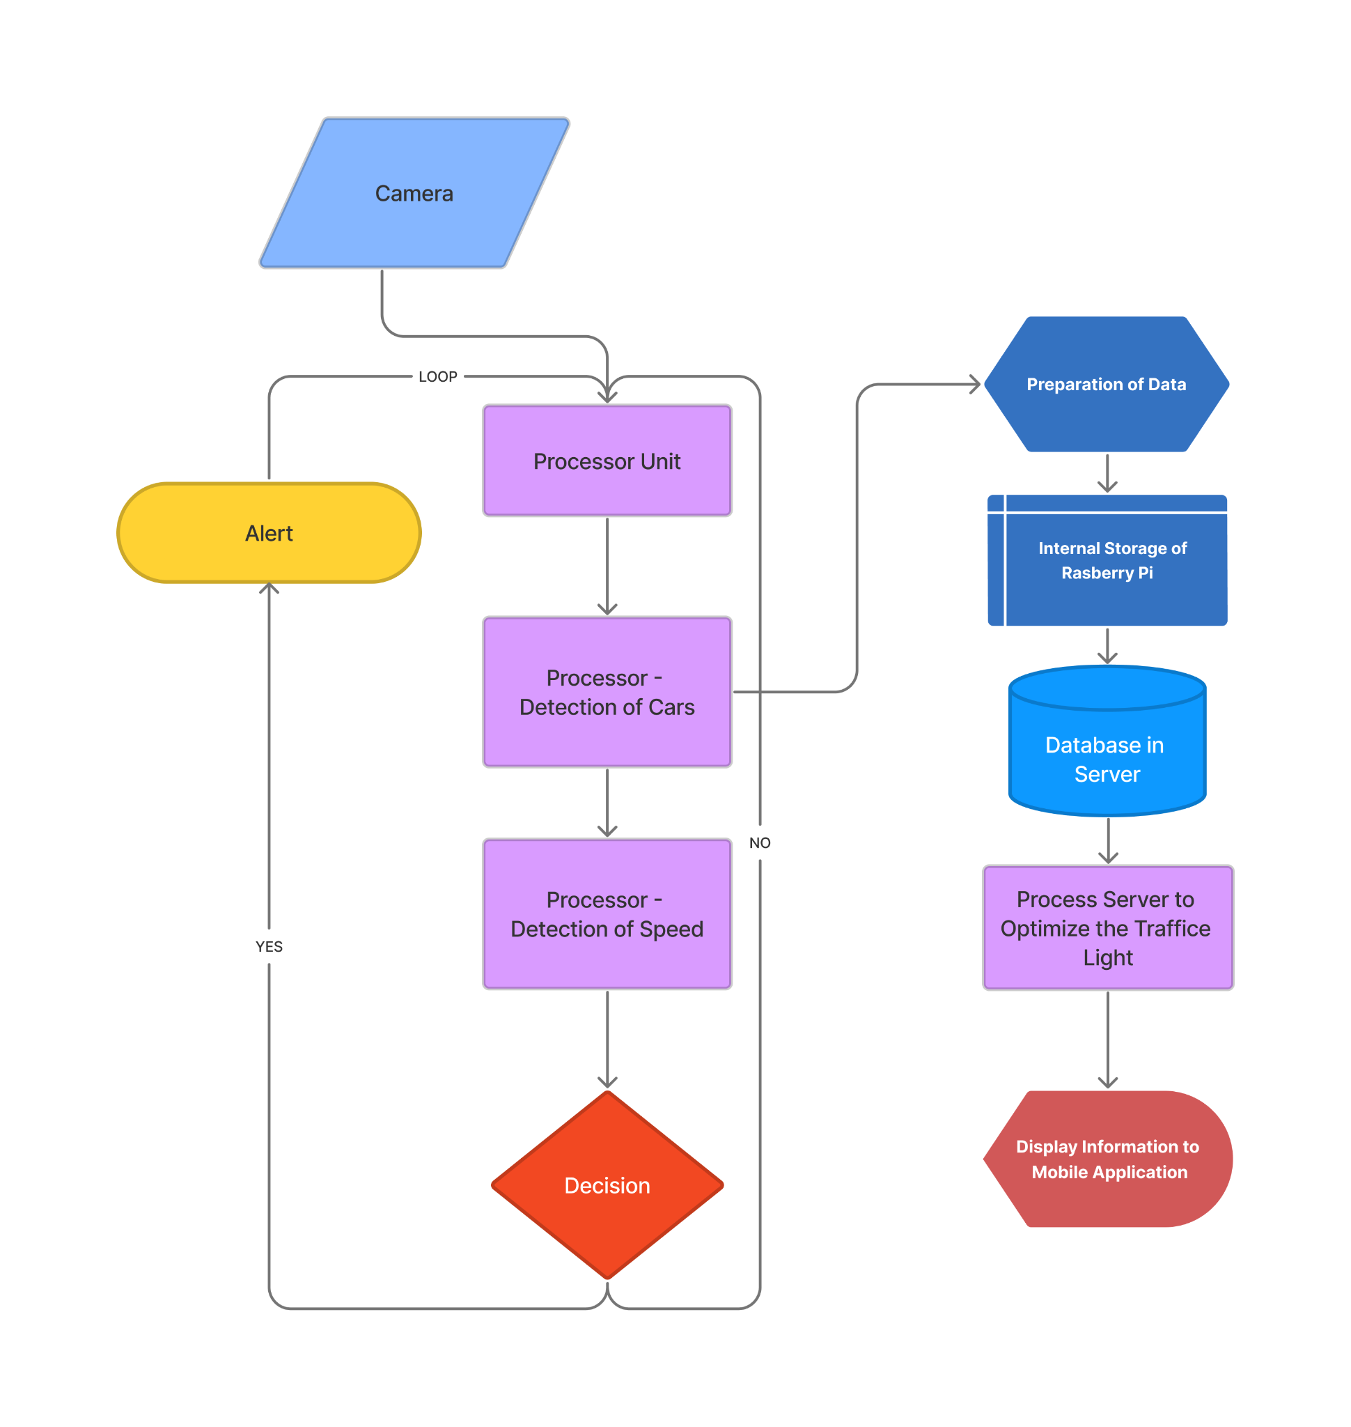

*Figure 4: Flow Chart*

Taking input from the camera module, the data sends information to the processor unit. The processor unit starts to detect the car pixel by pixel as a result there is a delay after the process detection car. Before making the decision, the processor will detect the speed of the cars and at the threshold it will send a signal to the Alert system.

In addition, the process of detecting a car is sending data to prepare a data module. It will store the processing image inside the raspberry pi. From the raspberry pi, there will be a cloud connection (firebase for instance) to the data inside a server. The server will process the data and will take the decision of the traffic light and send the data to the processor unit module. Then it will display to the user.

# ALTERNATIVES

## Camera Module Alternatives

1. Arducam [4]

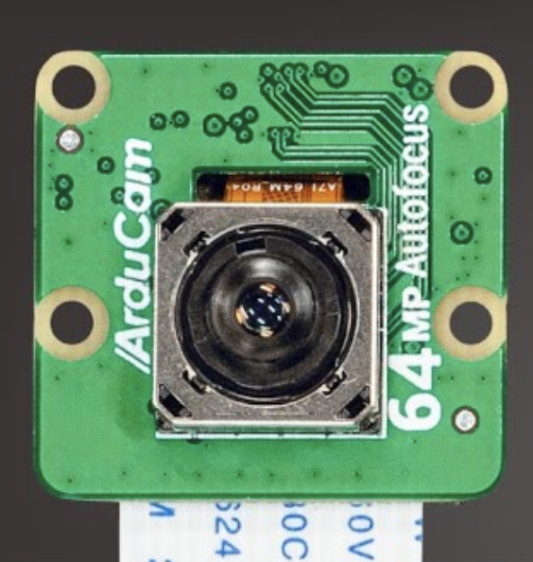

*Figure 5: Aducam*

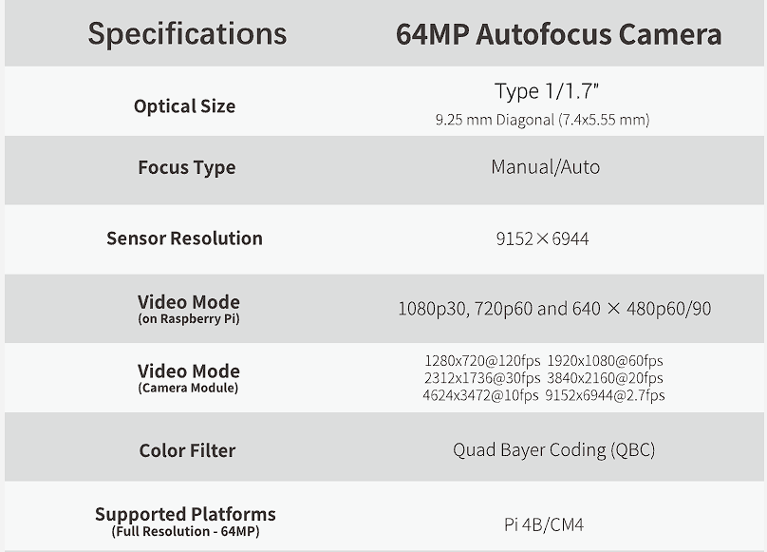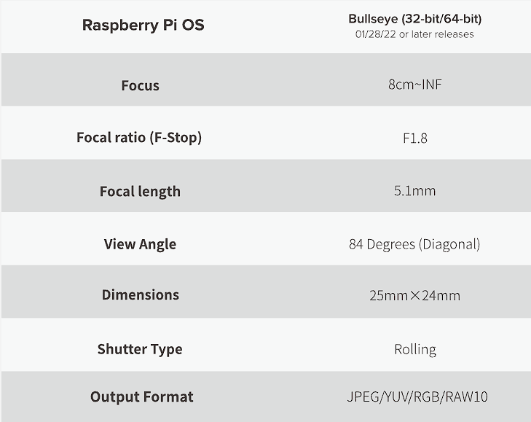

*Figure 6: Arducam specifications*

Characteristics:

The ArduCam has a very high 64MP camera. Moreover it is the flagship model for them. It has a breathtaking resolution and supports autofocus and manual focus up to 10x zoom. It supports different resolutions for video recording which is what we require for our project. It is supported with Raspberry Pi processors and hence easier for us to use for our project. Moreover, it records video at 90fps when we set it to a resolution of 480p and 120fps when it is recording the video at a resolution of 1280x720.

Advantages:

* The price is competitive, costs $59.99 USD
* 64MP Resolution camera
* 10x Digital Zoom
* Works on most Pis with a CSI-2 connection
* Best AutoFocus and Manual Focus
* Has a view angle of 84 Degrees

Capabilities: It is capable of recording 1080p video at 30Fps and 720p video at 60fps and 480p at 90Fps. It supports the latest version of Raspbian Operating System and software.

Cost : $59.99 USD on their website, arducam.com

## Raspberry Pi Camera Module V2-8 Megapixel [5]

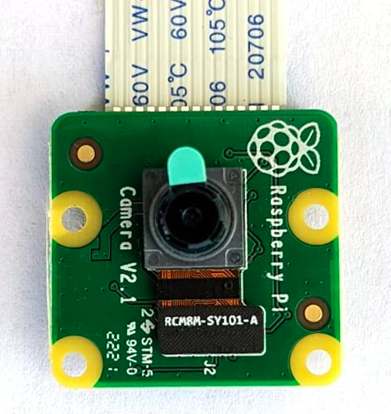

*Figure 7: Raspberry Pi Camera Module*

Characteristic :

The v2 Camera Module has a Sony IMX219 8-megapixel sensor. Supports 1080p with a wide-angle view of 3280 x 2464. The Camera Module 2 can be used to take high-definition video, as well as still photographs. It also comes with a processor, ram and ssd that is attached to the motherboard of the camera. The picture quality is average and good enough for the video. It also has the option to record video at 60fps for 720p resolution. It is typically used for surveillance, dashcam and other machine vision applications.

Advantages:

* Price is comparatively good at $49.99, ordered from amazon so should arrive in 2 to 3 days.
* It has a Core i7-4810HQ processor which is enough for image processing, and the cpu speed is 333Hz.
* It also comes with an ssd of 32GB and a ram of 2GB.
* It does not require any external camera cables.

Capabilities : It is capable of recording 1080p video at 30Fps and 720p video at 60fps. It supports the latest version of Raspbian Operating System.

Power: The recommended power supply is DC 5V and above 1.8A

Cost : $49.99 on Amazon

*Table 2: Verifying Requirements for Camera Module*

| Requirements from table x.x | ArduCam | Raspberry Pi Camera Module V2-8 Megapixel |
| --- | --- | --- |
| 1.1: The camera module should detect cars in between 10 to 60 m from the traffic light | It covers up to 100m | It covers up to 65m. |
| 1.2: The camera module should have a minimum detection angle width of 37.27 degrees | Covers 84 Degrees (Diagonally) | Covers 84 Degrees (Diagonally) |
| 1.3: The camera module should have a minimum detection angle height of 24.75 degrees | Covers 84 Degrees (Diagonally) | Covers 84 Degrees (Diagonally) |
| 1.4: The camera module shall record the video at 480p. | 480p (640 x 480)p | 480p (640 x 480)p |
| 1.5: The camera module shall work at a distance of minimum 60.25m5 while maintaining video quality. | Records videos up to 100m without losing its quality. | Records videos up to 65m without losing its quality. |

To conclude, we decided to go with ArduCam because, first of all, it meets all the requirements and also because it gives us some extra space to enhance our design if we later decide to add on to it. The pictures and video quality of ArduCam are more detailed and work well even in low light compared to the raspberry pi camera module. Moreover, the ArduCam is a 64MP camera whereas the raspberry pi camera is only 8MP. Hence we decided to go on with a better resolution camera. Moreover, the other comparisons such as the detection range was also another strong reason behind our choice.

## Processor Module Alternatives

# Raspberry Pi 4 Model B 2019 Quad Core 64 Bit WiFi Bluetooth (4GB) [6]

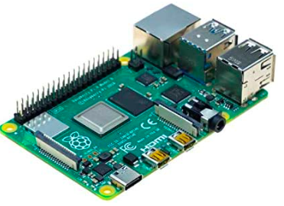

*Figure 8: Raspberry Pi 4 Model B 2019 Quad Core*

Characteristics/Advantages:

The Raspberry Pi 4 Model 2019 has a quad-core Cortex-A72 (ARM v8) 64-bit Soc. It is a small yet powerful computer capable of holding libraries, analyzing data, sending and receiving information via wifi…. It offers groundbreaking increases in processor speed, multimedia performance, memory (4GB), and connectivity compared to the prior-generation Raspberry Pi’s. It is for these various reasons that it is one of all alternatives when it comes to which processor we are choosing. Some of its advantages include:

* Price is fair at $269.99, ordered from amazon so should arrive in 2 to 3 days.
* Good for image processing (one of the fastest)
* Connection via Wifi and/or Bluetooth possible
* Quad core Cortex-A72 -> faster processing time
* 4096 MB of RAM (4GB)

# Rock Pi 4 Plus Rockchip RK3399(OP1) Single Board Computer LPDDR4 4GB with WiFi 5 and Bluetooth 5.0 Support Twister OS (4GB RAM+64GB eMMC) [7]

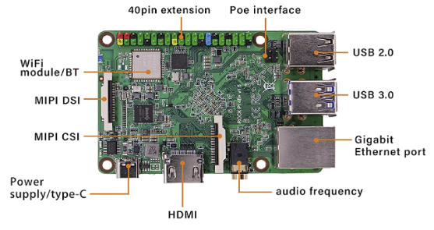

*Figure 9 : Rock Pi 4 Plus Rockchip RK3399(OP1)*

ROCK Pi 4 Plus is the upgraded version of ROCK Pi 4 Series,which is a Single Board Computer (SBC) in an ultra-small form factor that offers commercial users,makers, IoT enthusiasts, hobbyists,PC DIY enthusiasts and other a reliable and extremely capable platform for building and tinkering their ideas into reality.

Characteristics/Advantages :

* Price is fair at $164.71, ordered from amazon so should arrive in 2 to 3 days.
* Connection via Wifi and/or Bluetooth possible
* 64 Gb storage capacity
* 4096 MB of RAM
* Dual Core

*Table 3: Verifying Requirements for Detection Module (processor)*

| Requirements from table x.x | Raspberry Pi 4Model #: B 2019 Quad Core 64 Bit WiFi Bluetooth (4GB) | Rock Pi 4Model #: Plus Rockchip RK3399(OP1) |
| --- | --- | --- |
| 2.1: The detection module shall detect the incoming vehicles with an accuracy of above 90% through image recognition given our vehicle requirements | Requirement is met* | Requirement is met* |
| 2.2: The detection module shall count the number of incoming vehicles with an accuracy of above 90%. | Requirement is met* | Requirement is met* |
| 2.3: The detection module shall measure the speed of vehicles within 1 second. | Requirement is met | Requirement is met (less likely as a dual core) |
| 2.4: The detection module (processor) will have a memory of at least 1.9 GB, in order to hold the libraries required (such as OpenCV). | 4GB | 4GB |
| 2.5: The detection module (processor) shall have at least 1.4GHz7 single core in order to run the libraries at an appropriate speed. | 1.4GHz | 1.4GHz |
| 2.6: The detection module shall be able to connect to wifi in order to send information on the vehicles and their speeds. | Requirement is met | Requirement is met |

* : These rather depend on the libraries rather than the processors. Both processors will have a detection accuracy above 90% according to the OpenCV library that we will use to detect the vehicles. Furthermore, both processors have enough speed to detect the vehicle within 1 second.

To conclude on our findings, both of the above processors have met all the requirements for the detection module. The key difference between both, however, is that the Raspberry Pi Model B has a quad processor core whereas the Rock Pi 4 has a dual-core processor. In our design, a quad-core processor will accelerate image recognition and will therefore reduce time which is why we will thus take the Raspberry Pi Model B.

## Alerting Module Alternatives

The alerting module of the system will be a visual indicator that warns the drivers of the intersected road of a side collision potential if there is any.

As soon as our detection system determines a potential inability of a driver to stop at their designated yellow/red light, a signal will be sent to the alerting module to trigger a flash pattern that alerts the drivers of the intersected road.

The alerting system must meet and comply with the province’s regulations in terms of sign and light positioning, illumination intensity, and flash pattern.

The following figure illustrates the design of the alerting panel of our system:

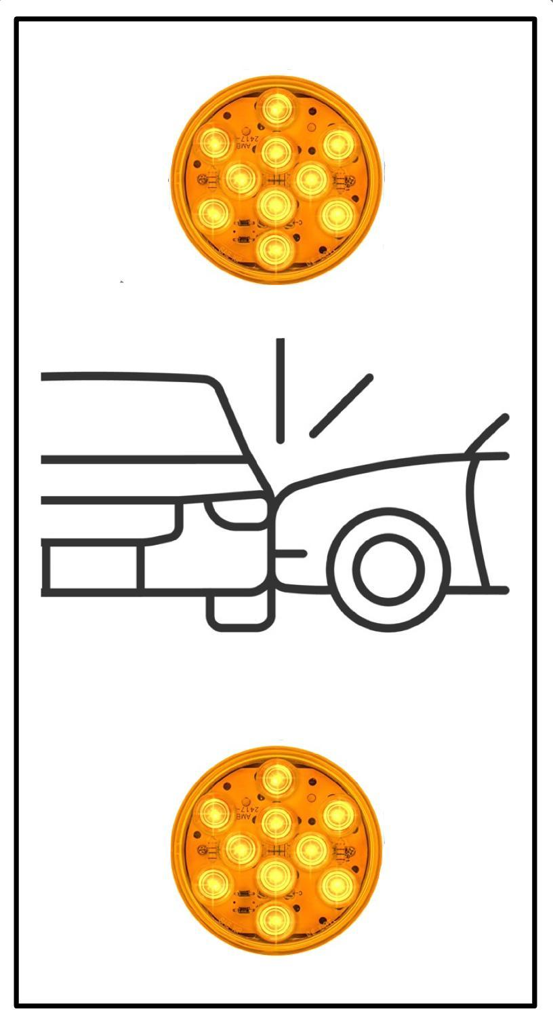

*Figure 10: Alerting Module Sign*

The alerting panel will feature a side collision sign indicative of the situation. The panel will be equipped with two round-shaped LEDs of 200mm diameter each.

The following alternatives were deemed suitable for our requirements:

*Table 4 requirements for alert module*

| **Requirements** | **Tacel Ltd**  Model #: DR4-YZFB-VLA | **Sunburst**  Model #: XH200-C02RYGD-2A |
| --- | --- | --- |
| 3.1 The Alerting Module shall broadcast a beam of light to its surrounding upon arrival of the alert signal | Requirement is met | Requirement is met |
| 3.2 Shall comply with all certification and regulation standards constituted by the city of Montreal | Compliance with:   * Intertek ETL Verified * ITE VTCSH LED Circular Signal Supplement | Compliance with:   * CE * EN12368 * RoHS * ISO9001 |
| 3.3 Shall be visible and able to distribute light uniformly and efficiently | Requirement is met as per compliance | Requirement is met as per compliance |
| 3.4 Shall operate with 120 V 60 Hz AC | Operates at 80-135V  (60Hz AC) | 120 - 230 VAC |
| 3.5 Shall have a luminous intensity range of 250-600 Cd | 410 Cd for yellow lights | > 600 Cd for yellow lights |

# DEVELOPING THE SOLUTION SELECTED

The Raspberry Pi 4B requires 5V DC, 3A input, this means that an AC to DC Power supply will be needed to change 120V AC coming from the main power source to 5V DC and will output 3A max.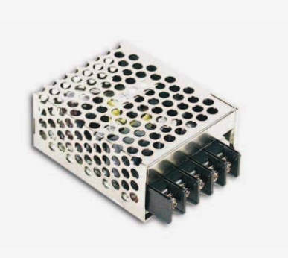

ASIN: B005T6UJBU

Item Model #: 1919043 Input: 88-264 V AC

Output: 5V DC, 3A and 15W

Since Raspberry Pi 4 Model B outputs a 3.3V, 16 mA signal, we will need to use a relay that uses the main power source to turn on the alerting module, with a 3.3V DC input to receive the signal from the controller.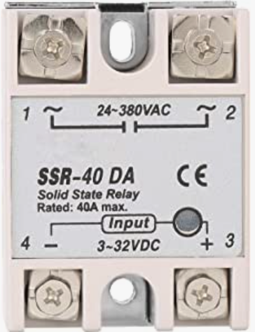

Control Voltage: 3 to 32 VDC

Power Source: 24 to 380 VAC

ASIN: B07JZF6973

A Pin Push Splice Cable Connector Conductor to connect all necessary wires.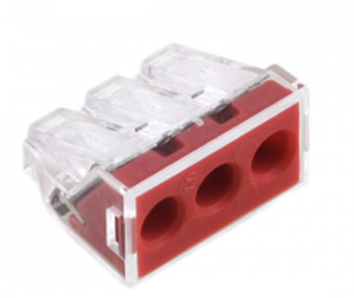

3 pin

14 gauge wires

push splice

Finally, the input power for all these components will come from the intersection pole.  
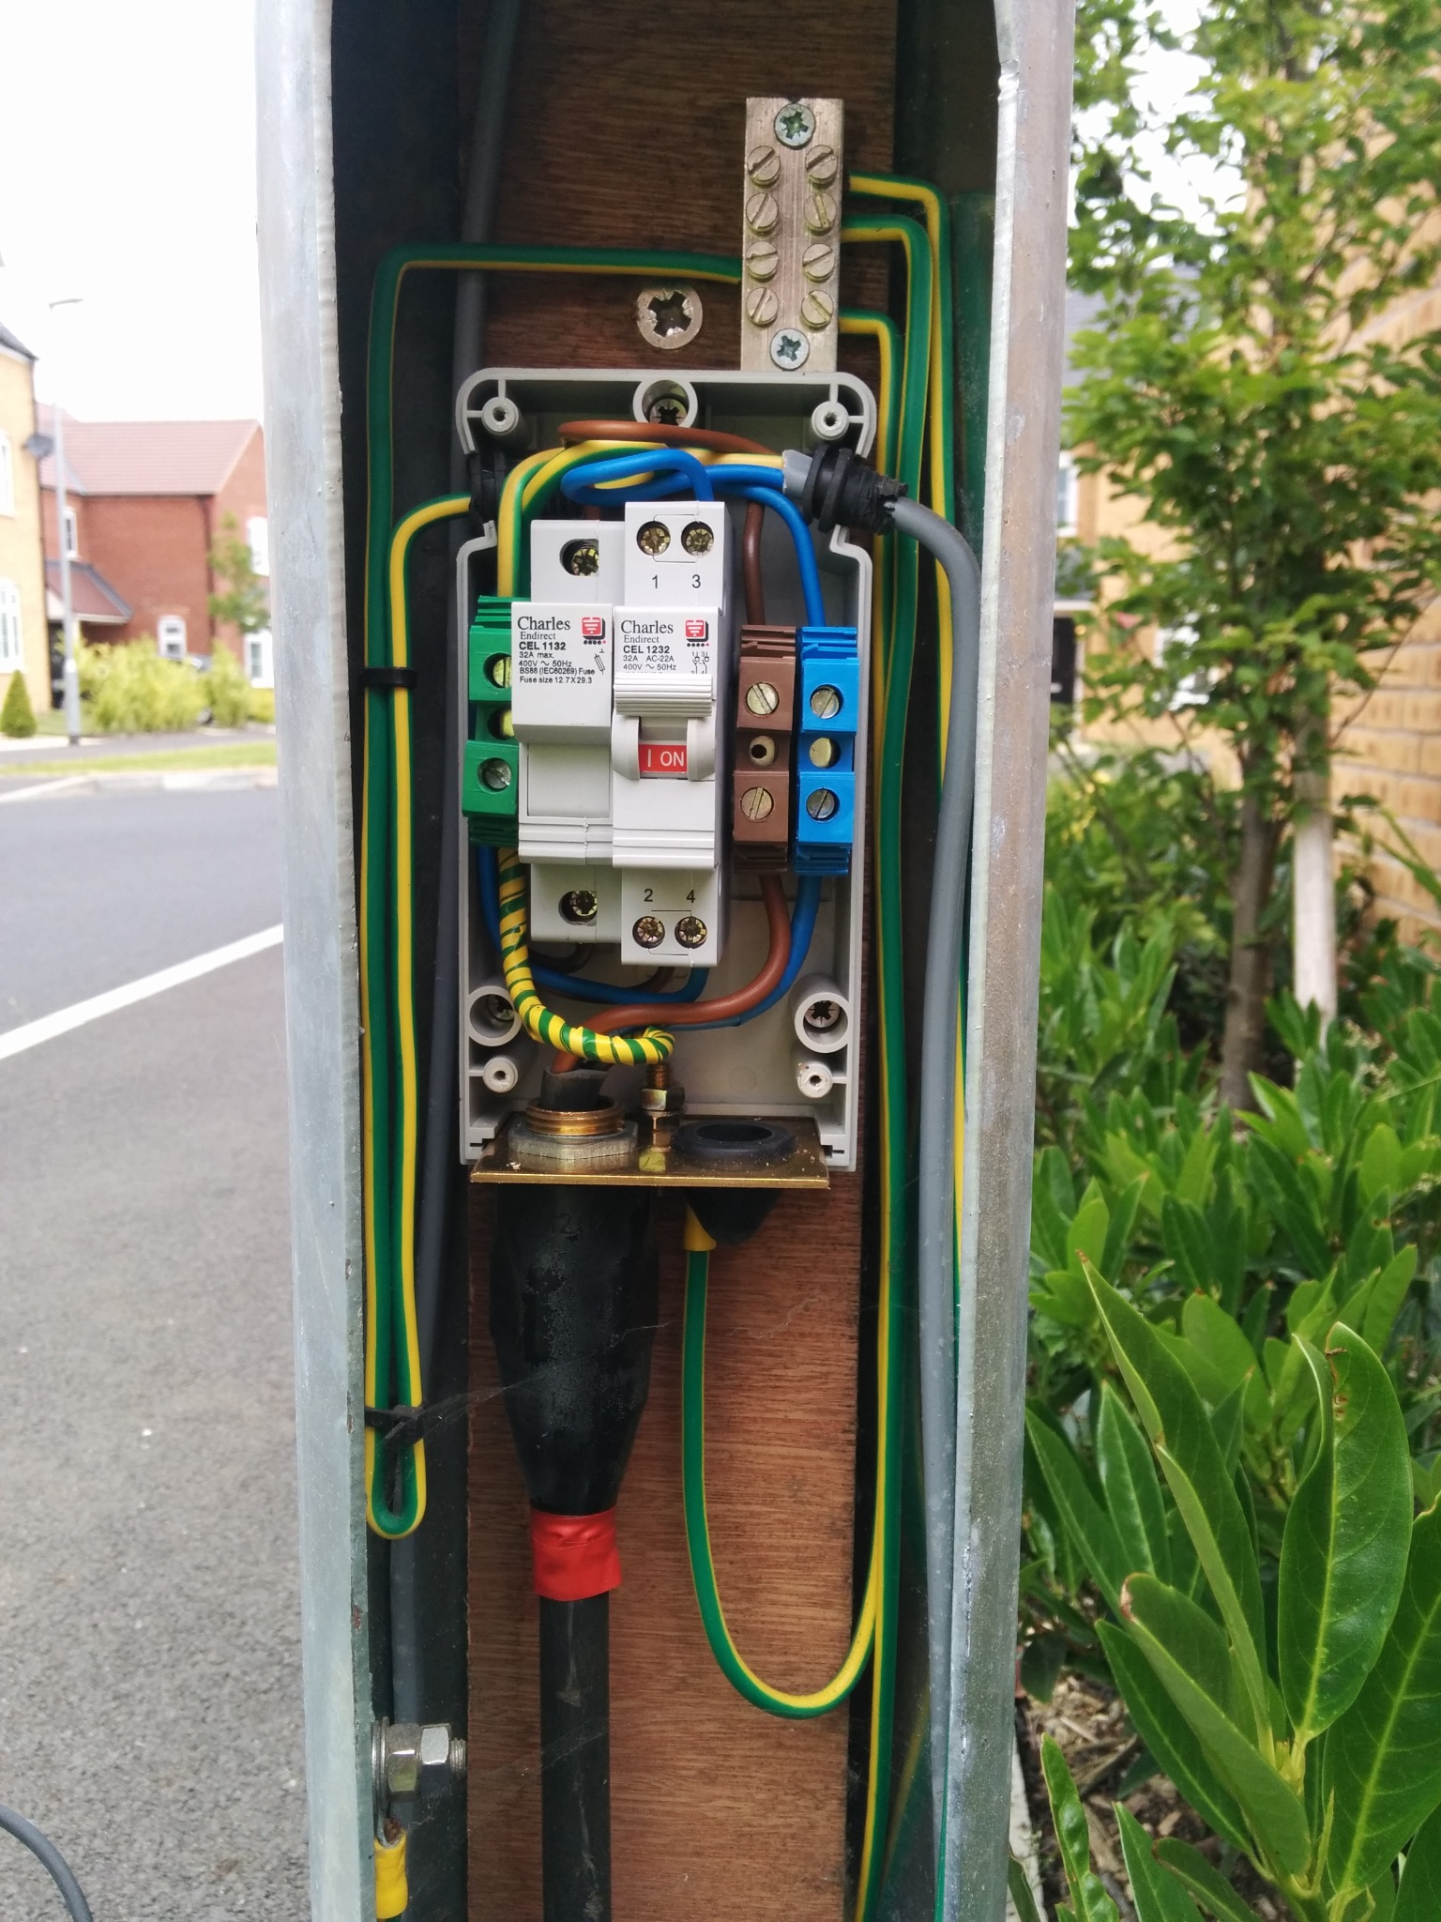

Inside of the intersection pole, we have 120 Vac which will  
  
power up the final design. The parallel connection of the 120   
  
Vac will not have an effect on other appliances whatsoever.

# DESIGN DEVELOPMENT - HARDWARE

To develop the final product of our system, the schematic diagram shown below illustrates the interconnection between the different system components.

The system will be powered using a 120V AC power source that will be connected to terminal blocks that will feed the other components.

The two light components in the Alerting Module will be powered from terminal modules connected to the power source with the help of a relay that gets a high or low signal from the Raspberry Pi based on the detection algorithm.

An AC to DC switch will be used to transform and convert the 120V AC power coming from the main source to a 5V DC that will feed the Raspberry Pi.

The Raspberry Pi will be connected to a camera module that will detect and send data to the microcontroller for analysis. The Raspberry Pi will communicate with a cloud database to send and receive data and determine whether or not a signal needs to be sent to the relay to enable the Alerting Module.

#1 : Raspberry Pi 4 (B 2019 Quad Core 64 Bit)

#2 : Arducam 64MP

#3 : Breadboard (later removed since unnecessary)

#4 : Fafeicy Single Phase, DC-AC Solid-State Relay

#5 : MEAN WELL RS-15-5 AC to DC Power Supply Single Output

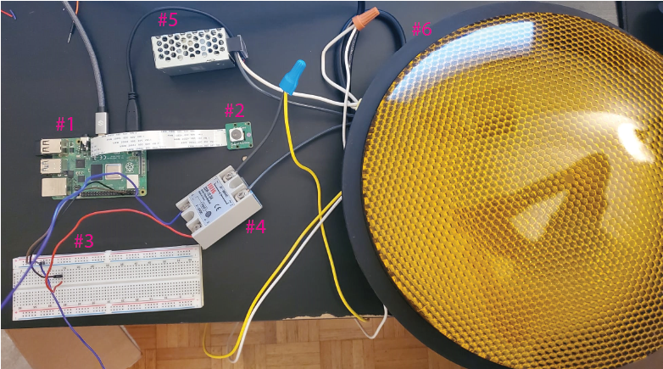

*Figure XX: Component placement and attachments*

*The picture below shows the final product inside of the box. it has the input and output cable, connectors on the box, all the electrical components and the camera attached to the box.*

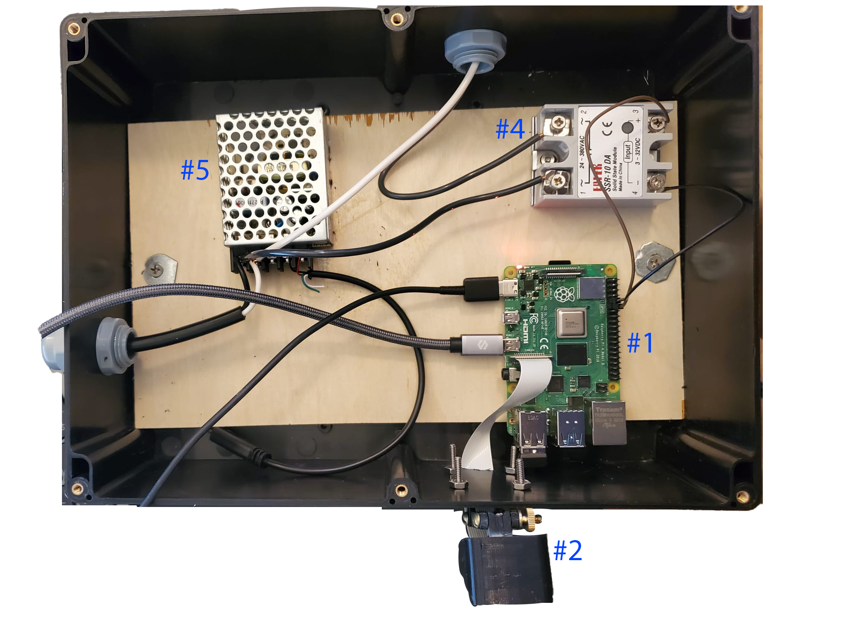

*Figure XX: Component placement within box*

*The electrical design below shows all the connections made in the project in detail.*

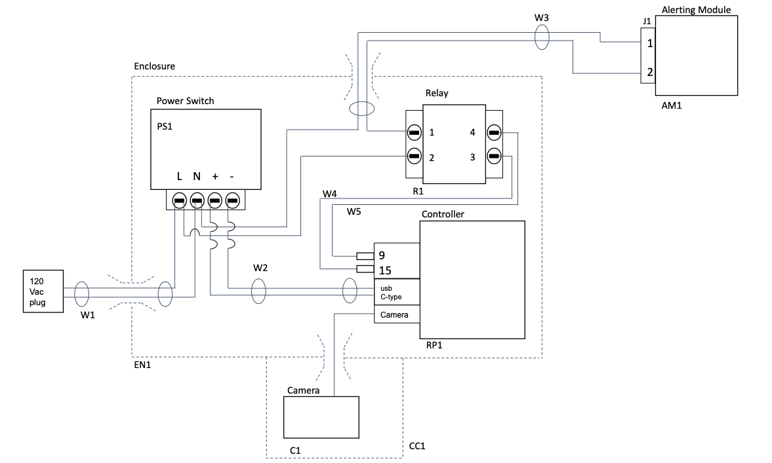

*Figure XX: IntersectionSafe electrical design*

The BOM will demonstrate the total cost of the design including hardware, electrical and software development.

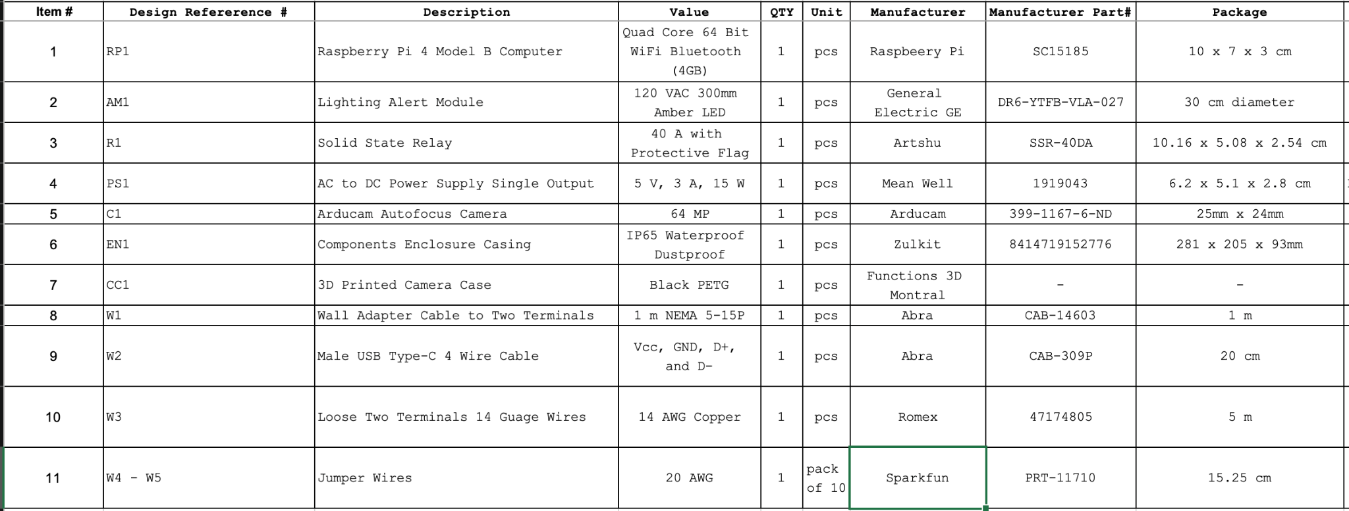

*Figure XX: IntersectionSafe BOM*

The box itself is a junction box in reality. However, this specific box meets all the requirements of the project. It is Waterproof and dustproof simultaneously. It is an ABS plastic electrical box which means it is an impact-resistant engineering thermoplastic & amorphous polymer. The attached small cover for the camera is made out of plastic which protects the camera from water and damages. In addition, the connectors used to bring in and out the electrical cable are also waterproof connectors. which makes the entire project water proof device. The camera box has the ability to rotate to any vertical position manually.

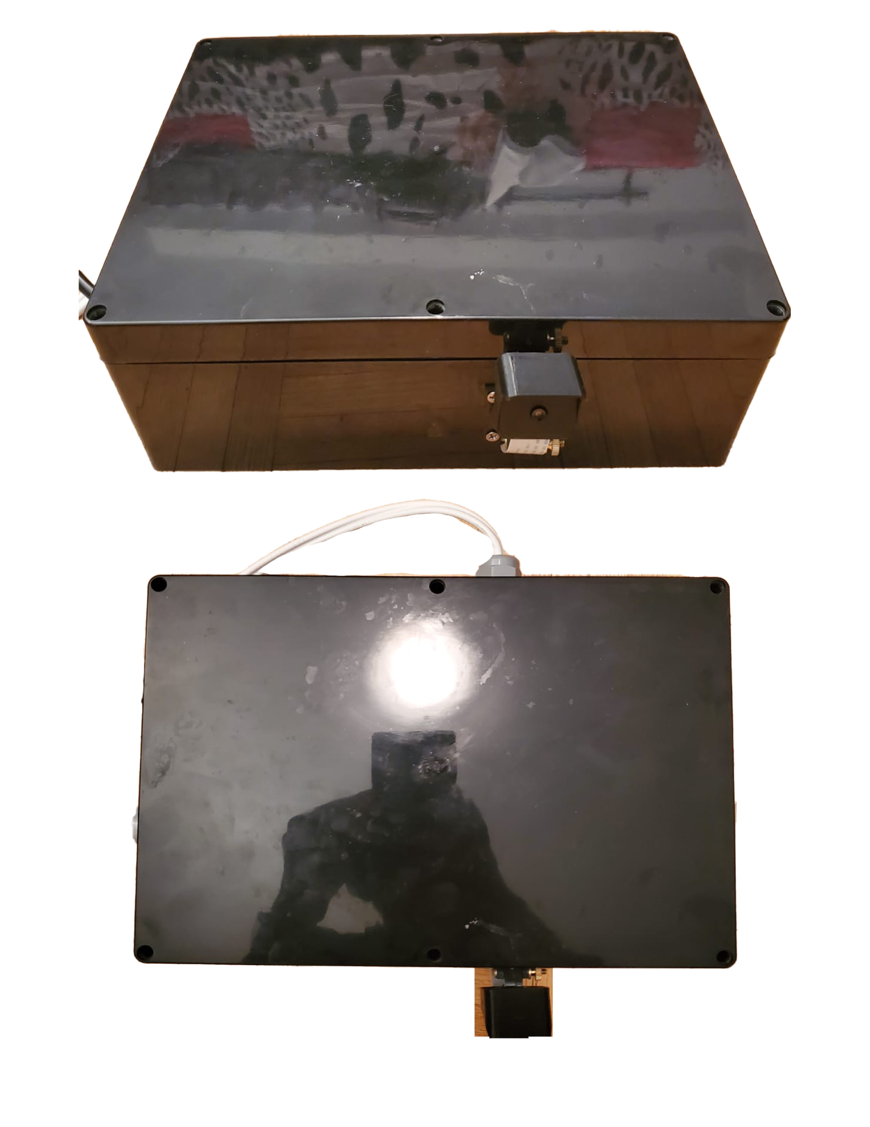

*Figure XX: Outside view of covering material*

# DESIGN DEVELOPMENT - SOFTWARE



**Raspberry Pi and Arducam:**

Arducam is a brand of camera modules and accessories for embedded systems and single-board computers, such as the Raspberry Pi. Arducam provides a variety of camera modules with different resolutions, interfaces and lens options, as well as adapters and extenders to make them compatible with different platforms. We access the camera from a python script.

The Raspberry Pi processor has a software IDE called ‘Genney’ to run the python script. Arducam is acting as the sensor to process the incoming vehicle's speed. To run the camera, we went to the official documentation of the Arducam and ran multiple commands using terminals. We had issues running the camera multiple times as we opened two of the camera windows and one of them was not responding. However, later we fixed the issue by putting a “false” preview for one of the camera windows.

In our python script, the speed of the vehicles are measured by differentiating the position of the vehicle in two different frames. Our script takes 2 frames and calculates the position in pixels covered by the vehicle. Knowing the pixel per metre value allows us to determine how many metres the vehicle has traveled. For instance, if a car has moved 4 pixels and the pixel per metre value is 8, then we know the car has traveled half a metre between those frames. Furthermore, knowing we have 18 frames per second, or a frame every 0.055 seconds. This means the car traveled half a metre in 0.055 seconds or 9.091 metres per second which equates to 32.73 kilometres per hour. This speed calculation happens for all vehicles at each frame. This is all encapsulated within a while true loop in order to continuously render the speed. Furthermore, a simple if statement within this loop verifies that all vehicles are safely under the preset limit. If the system detects a vehicle going above the limit and therefore at risk of crossing the red light, it turns on the alerting module and the light goes on.

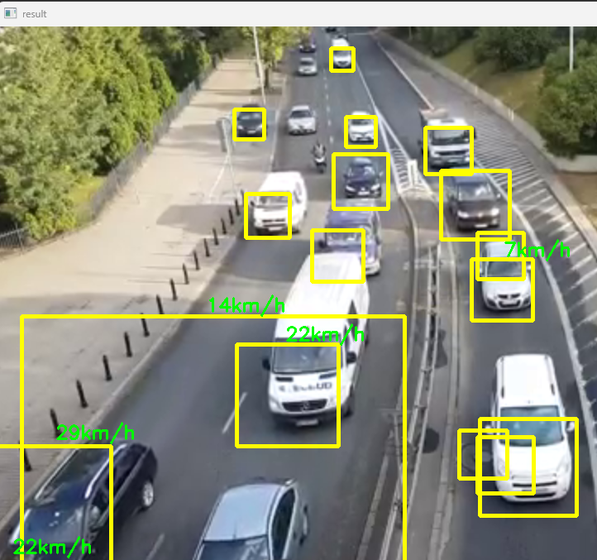

**OpenCV**

OpenCV is an open source software library which is mainly used for computer vision and machine learning. It enhances the vision for computer applications and machine learning. It uses an algorithm that is used to detect, recognize faces, identify objects like cars and identify moving objects and has many more abilities.

We have used it to identify and track the cars that are being recorded by the camera and produce an alert to the system whenever the detected car exceeds a certain speed(Speed limit of the road).

At first we used it on a pre-recorded video clip as the figure above shows, once it was verified, we used it on a live video clip to determine the speed of each car. Depending upon the speed the following measures have been taken to raise alert and also to keep record of the number of cars and their speed. These data are collected and sent to firebase.

**Firebase Database**

Firebase Database is an online real time database we have used to store our information generated by the IntersectionSafe device. The information is sent from the raspberry pi that was captured by the camera. It is then organized in the python code and sent to our online database.

In the database, information is stored in a hierarchical format. This can be seen in the screenshot below as Intersection has 2 sub sections HorizontalTraffic and VerticalTraffic. Each of these subsections store the information sent which includes cars per hour, number of cars right now, num of cars total as well as the time elapsed. As you may have concluded the cars per hour was determined by dividing the number of cars total by the time elapsed. The cars per hour value is the one that is the most important as it is this that will demonstrate how much traffic is going each way. If cars per hour in HorizontalTraffic is much larger than cars per hour in VerticalTraffic this indicates that the traffic is much greater horizontally than vertically. As a result, the optimized traffic should prioritize and give a longer green light to the horizontal than to the vertical traffic.

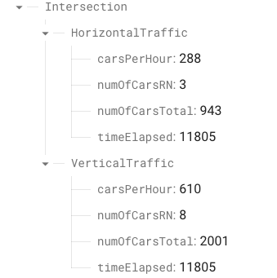

Furthermore, our firebase database also contains the list of our users. Any user who will enter their information and register with our app will be stored here. This way we can keep track of users and their emails in order to ask for feedback from them.

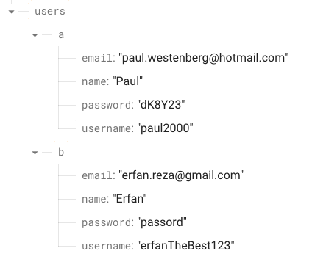

Once the information has been stored it is constantly being updated by the raspberry pi. It is then retrieved by the android studio application.

**Android Studio Application**

Android studio application is an application used to create mobile applications that can be used on android cellular devices. It is very open sourced and simple to use which is why we chose it in order to display the information of the intersection to the client. Furthermore, it is handy to have the information constantly at the tip of your fingers in order to make changes rapidly. This section details the android application of IntersectionSafe.

The app contains a register page where a user can sign up to our services. The information that needs to be entered are the name, user name, email, and password. If the user already has an account he/she can click on the message below to go to the sign in page for logging in with username and password. The interface for the registration page, as well as the sign in activity can be seen in the figures below:

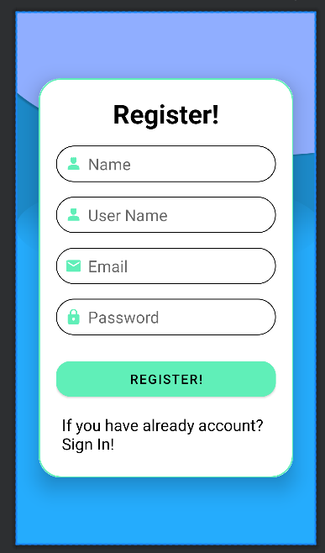

Fig: Register Activity

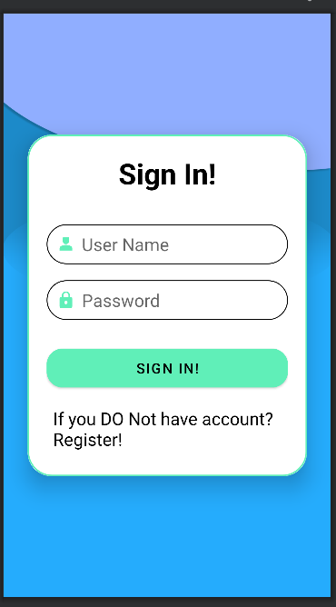

Fig : Sign In Activity

Once the user is inside the main page after signing in, the information of the IntersectionSafe will appear. This information is displayed as horizontal traffic and vertical traffic giving the statistics for both. In each traffic direction, we have the cars per hour, the number of cars right now, the total number of cars. Lastly, each traffic direction will have the optimized traffic light time needed in that direction. For instance, in the image below, the optimized green light time for the horizontal traffic would be 24.43 whereas that of the vertical traffic would be 40.57.

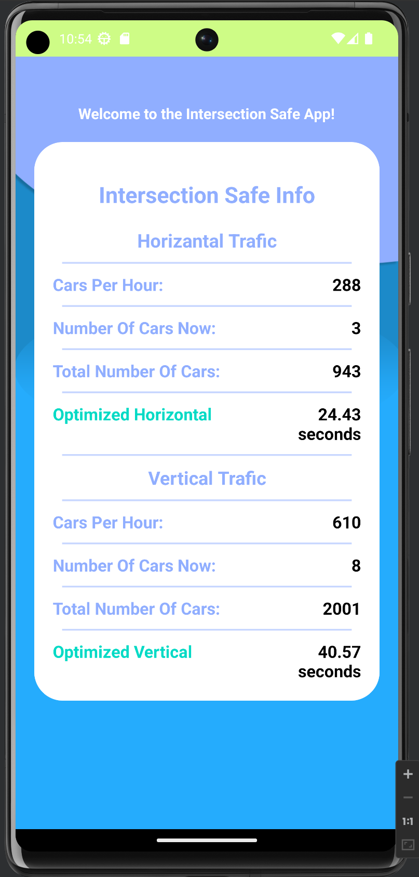

Main activity while it is receiving info from firebase

The optimized horizontal and Vertical Traffic were determined by using the following formula:

Optimized horizontal traffic =

15 + 45*(HorizontalcarsPerHour/(HorizontalcarsPerHour+VerticalCarsPerHour))

Optimized vertical traffic =

15 + 45*(VerticalcarsPerHour/(VerticalcarsPerHour+HorizontalCarsPerHour))

Both calculations are in seconds. 45 seconds is split depending on the cars per hour of each traffic direction. Logically, a direction that has more cars per hour should have more green light time and so it would end up having more of the 45 seconds than the other way. The 15 seconds on the other hand is only in the case where there are no cars going one way. That way, instead of being 0 seconds it will be 15 which will allow the cars to go once in a while.

## BUDGET

Below demonstrates the budget we would require from the department in order to fulfill the requirements of our product.

*Table 5 requirements of products*

| **Component** | **Model** | **Price** |
| --- | --- | --- |
| Arducam | No model | $59.99 USD -> 80.40 Cad |
| Raspberry Pi 4 | B 2019 Quad Core 64 Bit WiFi Bluetooth (4GB) | $269.99 Cad |
| Tacel Ltd | DR4-YZFB-VLA | TBD (~5 to 10$) |
| MEAN WELL RS-15-5 AC to DC Power Supply Single Output | 1919043 | $28.09 Cad |
| Fafeicy Single Phase, DC-AC Solid-State Relay | SSR-40 DA | $16.59 Cad |
| TB-PCT-103D PCT-103D 3 Pin Push Splice Cable Connector Conductor | TB-PCT-103D | $2.59 Cad |
| **Total** | | **$407.66 Cad** |

# TEST PLAN AND MEASUREMENT OF SUCCESS

In order for us to verify that the product is meeting the requirements and specifications, we have to test it out in a few scenarios to check and verify and set certain criteria to determine it as a successful project. At first, we identify which part of the project must be tested and check the scenarios with different input/situations. We then verify the corresponding result or output and check if the result is happening within the range of the sensors or not, and maximum range where the result is most accurate. Following this, we check the scenarios where the product is missing information or not working. In this way we would be able to know the limitations of the product and the main object to make the product as accurate as possible as it deals with vehicles, speed, road rules, and regulations. Hence it is very important to make sure to make the product work as precisely as possible as there would be scenarios where the results must be generated within a split second.

Before starting with the actual scenarios, we check if the sensors for detecting the speed and the microcontroller are giving the correct readings/output or not.

Below are the following scenarios where we will check the limitations of the product and their success rate and how we are assuring the reliability of the product:

For all of the below scenarios the Speed Limit of the road is 50km/h and the sensors are placed 35m and 40m away and all the success rates below are estimated and the device is not built and it is according to the calculations but we will have some numbers once we start testing the devices.

Test 1:

Identify vehicles stopped at a red traffic light and accurately measure their acceleration speed when the light turns green, without generating any false positive alerts.

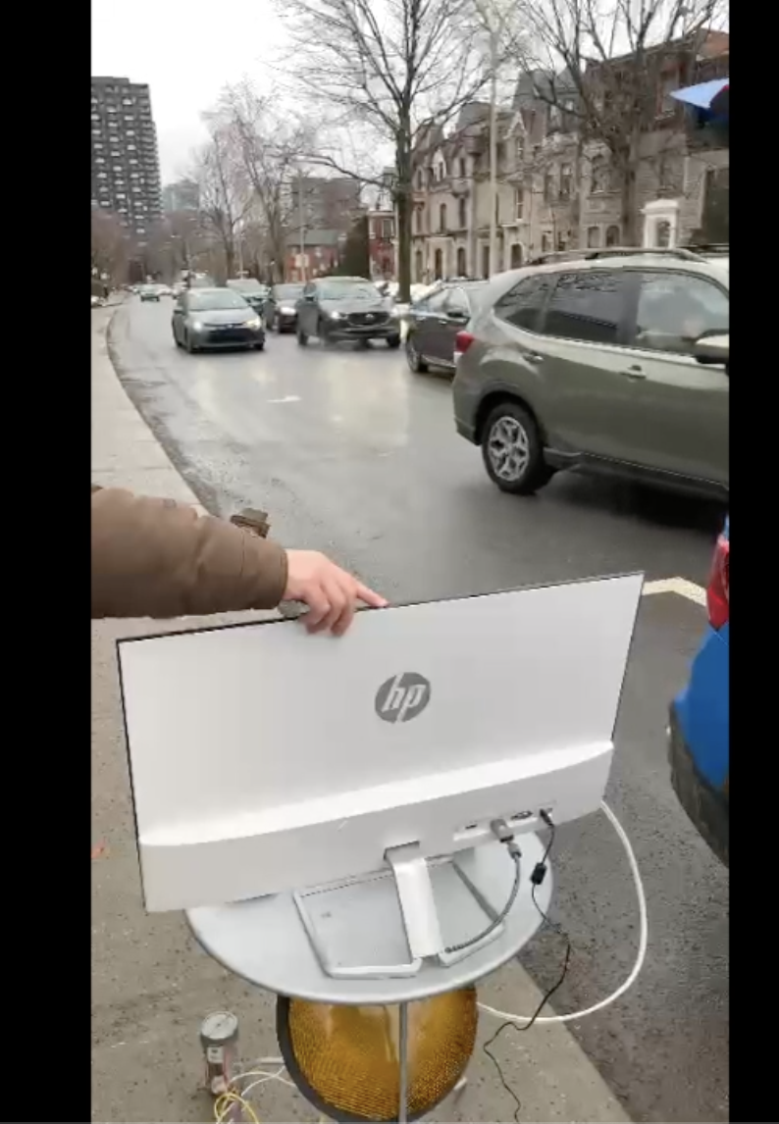

*Figure : Test 1*

Test 2:

Measure the velocity of approaching vehicles when they are traveling under 40 km/h and avoid generating false positive results.

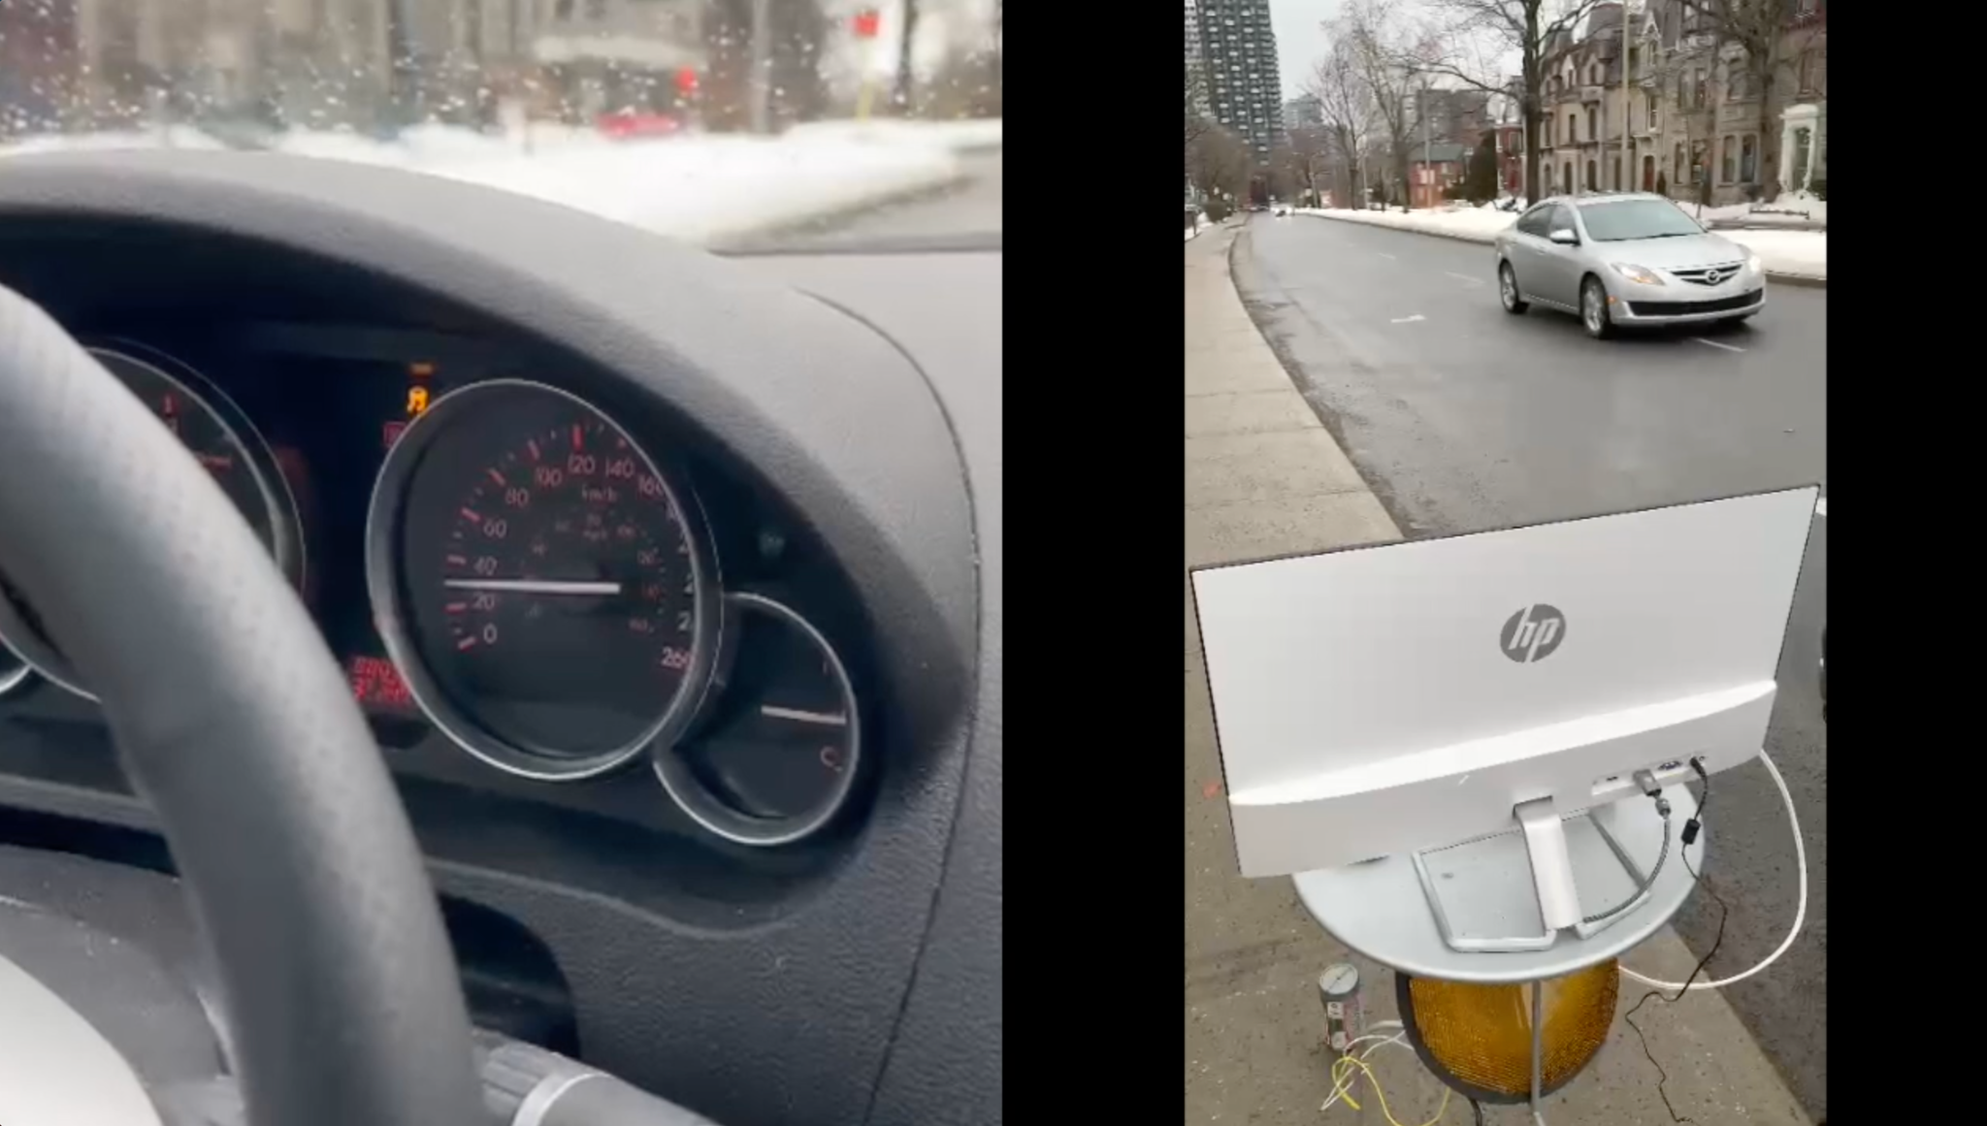

*Figure : Test 2*

Test 3:  
Measure the velocity of approaching vehicles when they are traveling over 40 km/h and alert true positive scenarios.

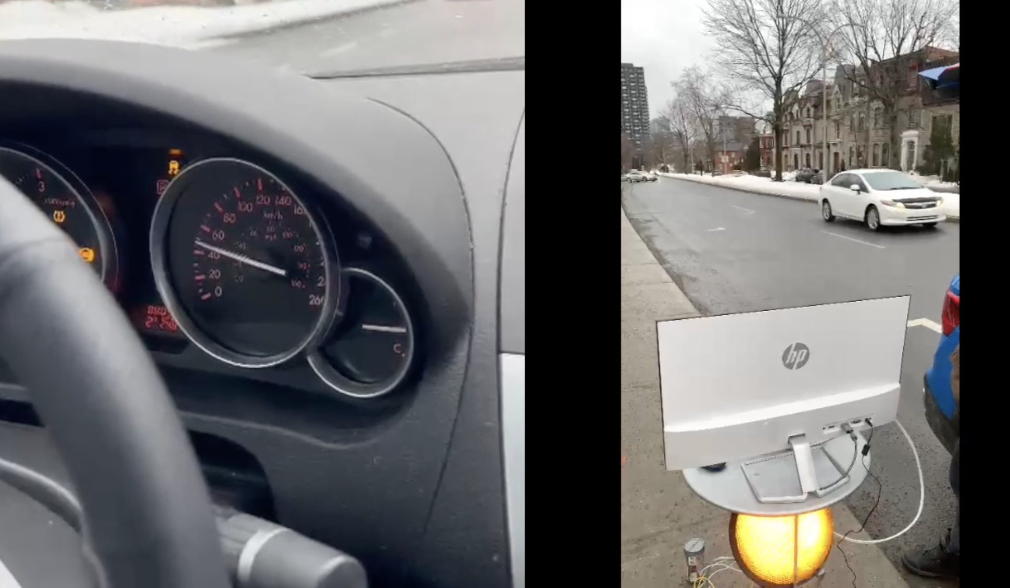

*Figure : Test 3*

**Test Performed - Results on 20 tests:**

10 above limit and 10 under limit:

| Real Situation -> Test | Car Above 40 km/h | Car Below 40 km/h |
| --- | --- | --- |
| Alarm went ON | 8 | 0 |
| Alarm didn’t go ON | 2 | 10 |

8 True Positives

0 False Positives -> very good

2 False Negative -> ok since this is what it would be like with no device

8 True Negatives

As we can see from the results, everything was accurate except for 2 false negatives. These are times when the alarm should have gone on but didn’t. This isn’t bad since it is basically what is at intersections right now. We will mention that Intersection is not a replacement for good judgement and despite the alarm not going on, one should always be aware when driving. All throughout our design we were focused on not having any false positives. We figured that having an alarm go on that shouldn’t be on is dangerous and can cause an unnecessary accident. Cars will suddenly break in the belief of an intersection which can cause vehicles behind them to crash. It was thus very important for us to have 0 false positives which we were able to obtain.

**Opencv and software Tests:**

At first we designed our software with opencv in a way so that it detects cars in a pre-recorded video clip and later with a live video from the ArduCam. These tests were performed on a standard size Quebec road with two lanes on each side of the intersection. The results were more or less satisfying as all the standard sized cars between a height of 1.22 - 1.83m and width of 1.45 - 2.12m were being detected and the speed was also shown. We were not confirmed about the speed of the cars in the pre-recorded video. It also had some issues such as sometimes 2 cars were being detected as one object and also giving unusual speed for the pre-recorded video. Later, while using it on the live video, no such issues were encountered. It detected the speed of cars from 20 to 80 km/h on a road with a speed limit of 50 km/h pm each of four roads in the intersection. We used two of our cars to check the speed limit and the corresponding signal being sent when the speed limit was surpassed.

**Constraints:**

We set the camera to human height level and then we modified our code in such a way that the speed limit of the road is 40 km/h, so that we do not go over the actual speed limit of the road while testing which would be illegal.

These tests satisfies requirements 1,2,3 from Table 1: requirements

**Conclusion**

In conclusion, with the completion of this project we have met all the requirements with some constraints. In summary our project is dealing with an Intersection Collision Safe system which will detect the cars at a four way intersection using a detection module and calculate the corresponding speed of the cars. The ones that are overspeeding will cause a signal to be generated which will be displayed on the alert module a yellow light will keep on blinking. These decisions will be made by the software with the help of the processor. It also collects the data at the intersection and sends it to the firebase which interns connect to the mobile app.

At the end of the day, this system will be an addition to the traffic system which will reduce the traffic congestion at the busy intersections and also help make decisions on the time for each traffic light to change from red to green on each side of the intersection.

Beyond a shadow of a doubt, our project was successful in many different ways. However, it has its failure parts too. The project was successful in the electrical, mechanical and software wise. it did generate necessary power by turning ON all the components, the mechanical parts were water proof and it keeps the cold out as much as possible. The software side is detecting all types of cars and their speed successfully. It is also sending alerts whenever expected without any issue. The only problem we still have is setting up the distance by analysing the pixels. We needed that to specify a point on the map. That point was calculated depending on the intersection and its speed limit to be able detect collision before its occurrence. However, since we are not able to generate the distance point, our project is acting as a police radar since it is detecting and alerting whenever a car passes the max speed.

If we had more time, we could have worked more on the coding part to be able to set a specific line on the picture to finish the project fully. If that specific part gets solved then the project will function on its full potential.

# TASK BREAKDOWN

## Phase 1

### Task 1.1 - Project Start up

1.1.1 Selection and Planning - Paul,Erfan,Rifadul,Saro,Jean,Mohammed

1.1.2   Project Selection and Team Formation - Paul,Erfan,Rifadul,Saro,Jean,Mohammed

1.1.3   Phase 1 Report Submission - Paul,Erfan,Rifadul,Saro,Jean,Mohammed

1.1.4   Phase 1 Presentation - Paul,Erfan,Rifadul,Saro,Jean,Mohammed

## Phase 2

### Task 2.1 - System Level Design

2.1.1 Select camera unit - Paul, Mohammed

2.1.2 Select main processing unit - Paul, Mohammed

2.1.3 Select transformer - Erfan, Rifadul

2.1.4 Calculate power requirement - Saro, Jean

2.1.5 Select supply unit and adapters - Saro, Jean

### Task 2.2 - Schematic Design

2.2.1 Design main processing unit circuit schematic - Saro, Jean

2.2.2 DesignPower electronic circuit schematic - Saro, Jean

2.2.3 Design control circuits for transmitter, receiver and transformer - Erfan, Paul

2.2.4 Simulate electronic circuits - Rifadul, Mohammed

## Phase 3

### Task 3.1 - Printed Circuit Board Design

3.1.1 Identify Manufacturing Constraints - Rifadul, Paul

3.1.2 Design PCB Layout for All Circuits - Erfan, Jean

3.1.3 Manufacture Printed Circuits - Saro, Paul

3.1.4 Populate the Printed Circuit Board - Jean, Rifadul

### Task 3.2 - Control System

3.2.1 Create Module for the Transmitter - Mohammed, Erfan

3.2.2 Design the Module for The Transmitter - Paul, Rifadul

3.2.3 Create Module for the Receiver - Mohammed, Jean

3.2.4 Design the Module for the Receiver - Jean, Mohammed

3.2.5 Create Module for the Transformer - Saro, Erfan

3.2.6 Design the Module for the Transformer - Saro, Jean

3.2.7 Collect Data from Sensors - Paul, Mohammed

### Task 3.3 - Software

3.3.1 Setup System Software and Development Environment - Mohammed, Paul

3.3.2 Interface with Transmitter - Erfan, Rifadul

3.3.3 Interface with the Receiver in Software - Mohammed, Paul

3.3.4 Implement Controllers for Control Systems in Software - Saro, Jean

3.3.5 Code for the Data Visualization in an Application - Erfan, Saro

3.3.6 Implement User Interface - Jean, Mohammed

## Phase 4

### Task 4.1 - Testing and Validation

4.1.1 Test Electronic Circuits - Rifadul, Mohammed

4.1.2 Test Sensor Modules - Erfan, Jean

4.1.3 Test Receiver Module - Saro, Paul

4.1.4 Test Transmitter Module - Rifadul, Paul

4.1.5 Test transformer Module - Jean, Mohammed

4.1.6 Test User Interface - Erfan, Saro

4.1.7 Test the alert System - Paul, Mohammed

# UPDATED SCHEDULES - Gantt Chart

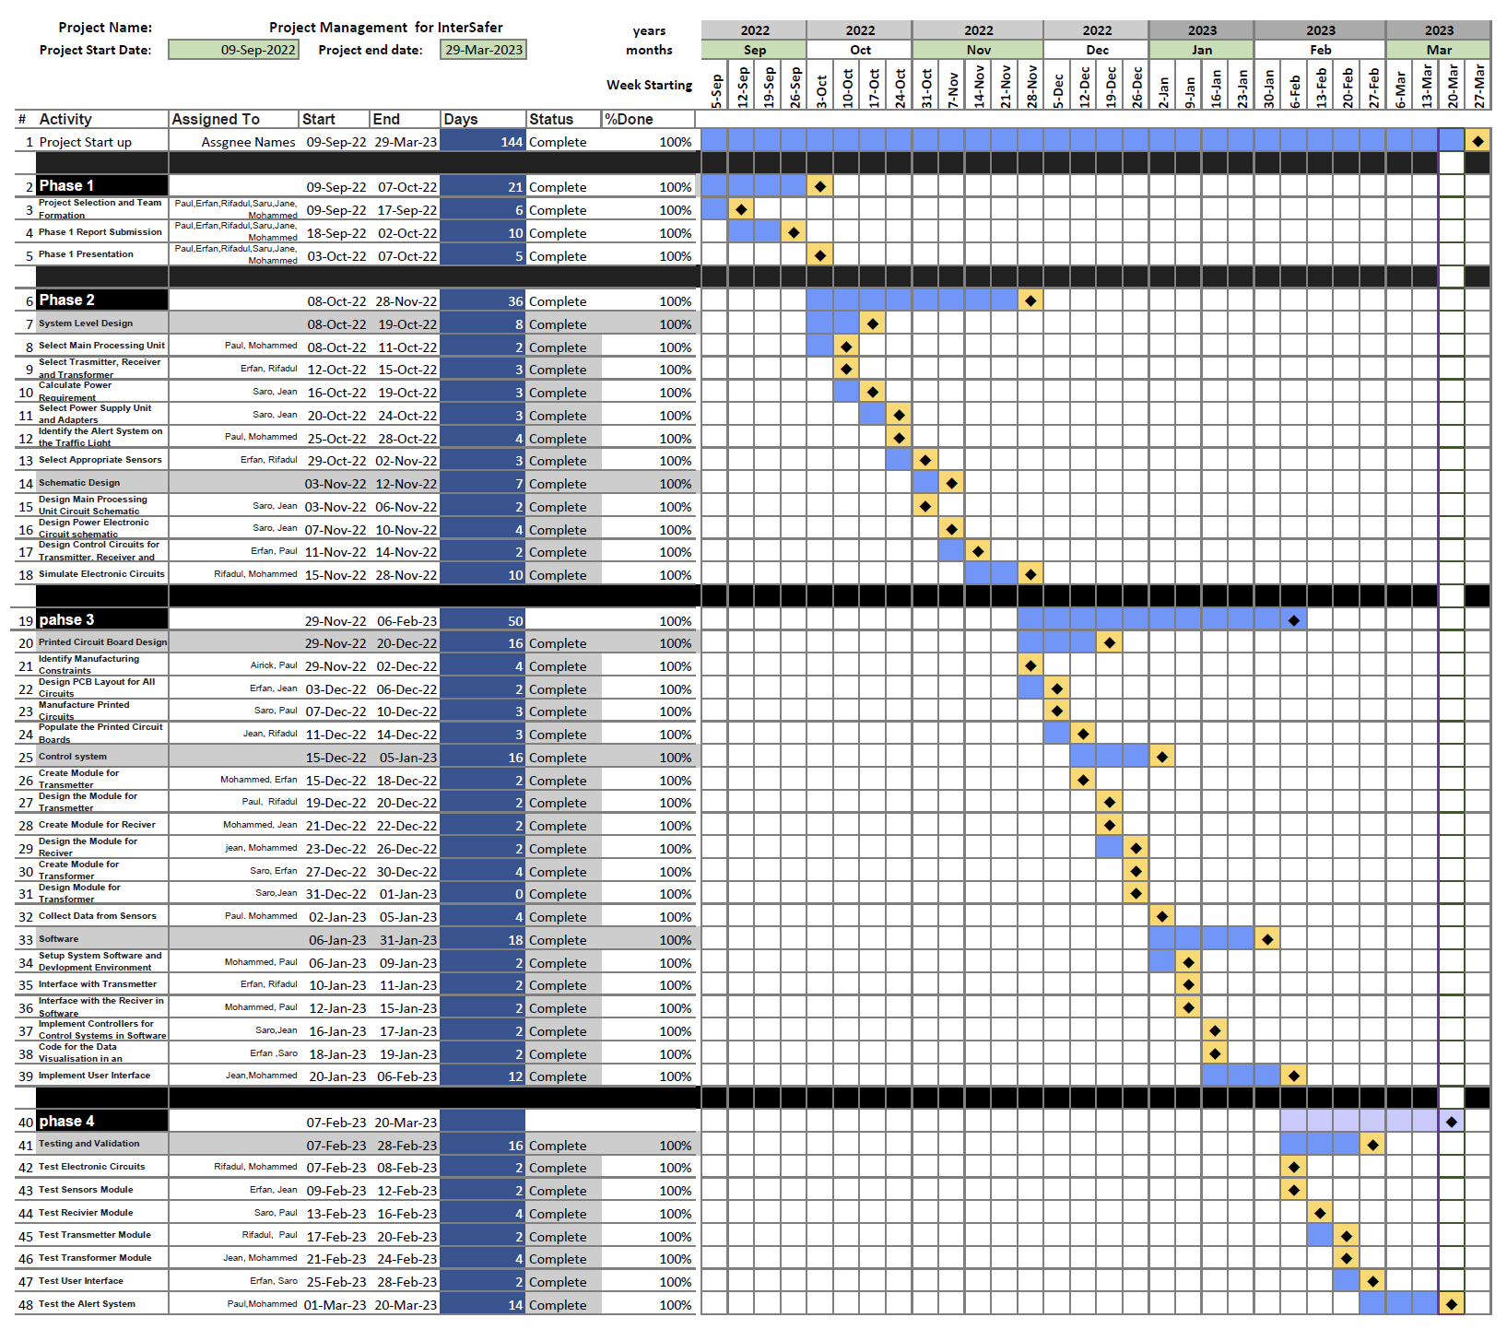

# ELSEE ASPECTS

In this section, we go over each of the components of the ELSEE aspects. These include ethical, legal, social, environmental and economical aspects. For each aspect, we will explain how our project affects or may affect this aspect. We will also provide examples of previous devices/examples similar to our project that have impacted these aspects. Furthermore, we will explain how we considered each aspect throughout the creation of our design.

## Ethical

There are several aspects to consider when looking at the ethical importance of IntersectionSafe. For starters, people will rely on the technology of IntersectionSafe with their lives. Seeing the IntersectionSafe light go off will alert them of a possible collision, enticing them to break rapidly. Of course, and we will mention this in the product’s manual, IntersectionSafe is not responsible for collisions and is not a replacement for safe driving under any circumstances. It is simply there to provide help and assist in detecting collisions before they occur.

That being said, as engineers, we have the responsibility to put out a working and efficient product. A collision on an intersection containing our product could result in major concerns on the efficiency of the device. More on this in the legal aspect.

Lastly, our product, having the ability to save lives, should not be used for profit purposes. Of course our goal, on top of preventing intersection collisions is to become a profitable business but this should not come in the way of our main intentions which is to prevent accidents on the road. More on this in the economical aspect.

## Legal

It is important to note that in society, if a traffic light malfunction and a collision occurs, the municipality can be held accountable according to (16) . This thus means that our product can also be held accountable in the case of a collision with no warning as the individuals were following our IntersectionSafe’s recommendation and still got into a collision. This means that there is a possibility of a lawsuit occurring in the event our product malfunctions. We thus need to be 110% sure that our device works before deploying it to the public.

Furthermore, it is hard to change the laws of the road. To be able to implement this device at an intersection, the government of Quebec or Canada (wherever it is being implemented) would have to add it to its laws of the road. For Quebec, this is in the ‘Société de l'assurance automobile du Québec’ (SAAQ) that can be viewed in (17). The process of creating a new road law in Quebec takes a lot of time as it requires a lot of consideration and decision-making from Quebec authorities. Regardless, in order to implement our product, we would need to add our device’s information and its functionalities to the laws of the road. This would help citizens understand how it works, and what to do when the light turns on as they can view it on the SAAQ website.

Furthermore, once the law has been implemented inside the SAAQ’s laws, the driving schools, as they are the ones who teach people how to drive, will need to be told to start teaching this new aspect of the road. This won’t be an instant change and may take several years to implement and for people to see as a typical intersection light but it would need to start somewhere. This is typical whenever any new law is implemented. There are always several years where people take time to know what the device does.

Lastly, since our device is only applicable on intersections, an idea would be to just implement it on the island of Montreal. This is similar to the law of not being able to turn right on red which also only occurs on the island of Montreal. However this would mean that upon entry on the island of Montreal, drivers would have to be alerted of this which is hard to do.

## Social

When implementing a new road law, it takes time for the population to understand the purpose of the device. There is an adapting period where, although the law has been created, people still don’t quite know what it is. We would thus need to advertise and find ways to explain and educate the population on the device and what to do when the light goes on.

An important aspect to consider when talking about the social aspects of our device is potential breath in privacy. The Office of the Privacy Commissioner of Canada in (5) has many laws over cameras in a public environment. For instance, it explains how “Public consultation should precede any decision to introduce video surveillance” meaning in order to implement IntersectionSafe at an intersection, public consultation would be necessary. We would thus need the approval of the public in order to have our camera operational in that environment.

However, the public's real concern is in facial recognition through image processing. The concern is that it leads into a Big Brother society where everyone’s every move is being monitored. A solution and proposal to this would be to blur all faces and walking bodies of our camera as our only concern when filming is to know the speed of the vehicle. This proposal would help ease the proposal of implementing our device. Furthermore, our device would have to comply with the 15 laws under the “Scope of Application” section of (5).

The final concern is the extra stress this product can have on potentially already stressed drivers. A lot of drivers often feel stressed on the roads. Adding another light at intersections could simply increase their nervousness. The problem is that the light needs to be bright enough to raise the collision warning but not too bright as to make people panic. This perfect light brightness will be found through test trials as well as public feedback.

## Environmental

Environmental aspects also come into play as our product’s secondary goal is to help reduce air pollution. Our project focuses heavily on reducing traffic and chances of accidents at the intersection which in turn reduces air pollution. This happens as our device optimizes the green/red light ratio depending on the vehicle history which in turn results in better fuel efficiency of the vehicles.

Moreover, our product would also reduce fuel consumption which would help reduce the use of fossil fuel. With the decrease in traffic, it would simultaneously reduce the noise pollution that is caused by the traffic. Secondly, our device materials are very eco-friendly, we use a small amount of material to design our device cover and hence very little or no plastic would be used as plastic is also one big environmental problem that we have now as it takes up a lot of time to decompose(450 years) according to (3).

Lastly, according to *Hydroélectricité*, as we are developing the power from Quebec, the power we are using for our project is 99% renewable as in Quebec 94% of the energy is produced by Hydro and the other 5% is produced from wind. This is a very important aspect of our project that we wanted to mention.

## Entrepreneurial/Economical

Our device will also play its part on the economical side. For instance, there will be less gas consumption because of the optimized traffic system, reducing the driver's cost in gas. In addition, an optimized traffic light system will help reduce travelling time for drivers. In addition, maintenance costs will go down as there will be fewer accidents.

From an entrepreneurial aspect, new shareholders might be interested in our product as the modern society is moving towards autonomous cars and our technology will help to optimize and reduce side impacts drastically. Initially our idea is to rent or sell devices to the city of Montreal then we can expand our business slowly all over Canada. An additional feature of our products to collect data of an intersection: the number of cars, accidents, speed which can be sold and used to optimize traffic light systems. All these aspects can be useful to society meaning we will be able to sell or lend out to governments our product IntersectionSafe. According to (6), “If you’re talking about the costs the government has to pay, the costs can range anywhere from as little as $80,000 to more than $500,000 to purchase and install the traffic lights”. This shows that the government is keen on spending money on traffic infrastructures in order to reduce collisions and increase safety. This in turn means that our product has value and will be carefully examined and considered.

# ELSEE REFERENCES

# Bibliography

| [1] | "bowenpainter.com," Bowen Painter, 2022. [Online]. Available: <https://bowenpainter.com/blog/what-if-i-had-a-car-accident-due-to-malfunctioning-traffic-lights/> . |
| --- | --- |
| [2] | "saaq.gouv.qc.ca," Société de l'assurance automobile du Québec, 2016. [Online]. Available: https://saaq.gouv.qc.ca/en/saaq/documents/laws-regulations. |
| [3] | "mern.gouv.qc.ca," Ministère des Ressources naturelles et des Forêts, 2016-2022. [Online]. Available: <https://mern.gouv.qc.ca/en/energy/hydroelectricity/> . |
| [4] | "savemoneycutcarbon.com," SaveMoneyCutCarbon, 2022. [Online]. Available: <https://www.savemoneycutcarbon.com/learn-save/how-long-does-it-take-for-plastic-to-biodegrade/> . |
| [5] | "priv.gc.ca," Office of the Privacy Commissioner of Canada, 02 March 2016. [Online]. Available: <https://www.priv.gc.ca/en/privacy-topics/surveillance/police-and-public-safety/vs_060301/> . |
| [6] | "howmuchisit.org," T2 Web Network, LLC, 2022. [Online]. Available: <https://www.howmuchisit.org/traffic-light-cost/> . |

# References

| [1] | "answers.opencv.org," Ooen CV, 2012-2018. [Online]. Available: <https://answers.opencv.org/question/179923/laptop-minimum-system-requirement-for-opencv/> . |
| --- | --- |
| [2] | "qengineering.eu," Q-engineering, 2022. [Online]. Available: <https://qengineering.eu/install-opencv-lite-on-raspberry-pi.html> . |
| [3] | "ite.org," Institute of Transportation Engineers, 2022. [Online]. Available: <https://www.ite.org/pub/?id=e26a6f93%2D2354%2Dd714%2D51c9%2D7fc16b2c6082> . |
| [4] | "arducam.com," Arducam, 2022. [Online]. Available: <https://www.arducam.com/64mp-ultra-high-res-camera-raspberry-pi> . |
| [5] | "Official Raspberry Pi Camera Module," amazon, 2022. [Online]. Available: <https://www.amazon.ca/dp/B0B1BD951M?tag=bestproductscanada2021-20&linkCode=osi&th=1> . |
| [6] | "Raspberry Pi 4 Model B 2019 Quad Core 64 Bit WiFi Bluetooth," Amazon, 2022. [Online]. Available: <https://www.amazon.ca/Raspberry-Model-2019-Quad-Bluetooth/dp/B07TC2BK1X/ref=asc_df_B07TC2BK1X/?tag=googleshopc0c-20&linkCode=df0&hvadid=335380394635&hvpos=&hvnetw=g&hvrand=13237999348762342001&hvpone=&hvptwo=&hvqmt=&hvdev=c&hvdvcmdl=&hvlocint=&hvlocphy=90> . |
|  |  |
| [7] | "Rock Pi 4 Plus Rockchip RK3399(OP1) Single Board Computer LPDDR4 4GB with WiFi 5 and Bluetooth 5.0 Support Twister OS (4GB RAM+64GB eMMC)," Amzon, 2022. [Online]. Available: <https://www.amazon.com/Rockchip-Computer-Bluetooth-Support-Twister/dp/B09JYNSHRX?th=1&language=en_US&currency=CAD> . |
| [8] | "tac-atc.ca," tac-atc, 2022. [Online]. Available: <https://www.tac-atc.ca/sites/default/files/site/doc/Bookstore/ptm-ledsgn-e.pdf> . |
| [9] | "rsr.transports.gouv.qc.ca," Gouvernement du Québec, 2013. [Online]. Available: <http://www.rsr.transports.gouv.qc.ca/Commun/QuitterApplication.aspx> . |
| [10] | "tacel.ca," Tacel Ltd., 2022. [Online]. Available: <https://www.tacel.ca/products-services/traffic-signal/led-modules/vla-led-signal-modules#documents> . |
| [11] | "traffic-lighting.com," Wuxi Anbang Electric Co, 2016. [Online]. Available: <https://www.traffic-lighting.com/product/Traffic-Led-Module.html> . |
| [12] | "ite.org," Institute of Transportation Engineers, 2022. [Online]. Available: <https://www.ite.org/pub/?id=e26a6f93%2D2354%2Dd714%2D51c9%2D7fc16b2c6082> . |
| [13] | "autoaccident.com," Edward A Smith Law Offices, 2022. [Online]. Available: <https://www.autoaccident.com/statistics-on-intersection-accidents.html> . |
| [14] | "nepal.ubuy.com," Ubuy Co, 2022. [Online]. Available: <https://www.nepal.ubuy.com/en/product/4DIDJCZLO-rock-pi-4-plus-rockchip-rk3399-op1-single-board-computer-lpddr4-4gb-with-wifi-5-and-bluetooth-5-0-support-twister-os-4gb-ram-64gb-emmc> . |
| [15] | "en.wikipedia.org," Wikipedia, 2022. [Online]. Available: <https://en.wikipedia.org/wiki/480p> . |

# APPENDIX

**Each Team Members Contribution**

**Paul Westenberg 40087074:**

I was heavily involved in making the requirements for each of the components of our design. This involved many of the calculations done in the first part of the report. For instance the calculation on the angle of which our camera had to have, the distance required for it to have and so on… From these calculations, I created requirements so that my teammates would make informed decisions on which components to choose.

Furthermore, I worked on choosing the camera components that fit our requirements. This involved a lot of research as our requirements were specialized to fit our design. Following this, I had found 2 potential camera’s that were suitable for our design. We then, with the team, compared both of them and decided on one.

I also helped heavily in setting the requirements for our processor. The included setting the processing power in order to be able to run open cv. Similarly to the camera module, I then compared 2 different processors we had chosen with our requirements and chose the best one (the one that fit our requirements best). I helped Mohammed position our components and design the general layout of our solution.

Moreover, I combined all the components cost in order to find our appropriate budget. I then went back on the previous options for components to see if we could diminish this cost.

Lastly, I wrote a large part of the ELSEE section. After our meeting with Farah, we had a lot to discuss as this project is heavily involved with ELSEE aspects, especially social and legal. I had to look up previous examples of a similar product being in society and the potential legal and social impacts it caused in order to maximize our products efficiency.

**Erfan Reza 40080730:**

I was mostly working on the component selection and calculation for our requirement part. As for phase 1, our requirements were kind of vague. So, the initial task was to make the requirement as clear as possible. Considering the different components of our device, I was working on the processor part. Selecting the correct processor like raspberry pi and rock pi. Also, comparing their character with respect to our project was a big part of this phase 2 report.

Moreover, I was working on the documentation like the processor, camera specification and comparison with different models. How to integrate with our system so that the image processing happens faster to meet our requirements. These are critical aspects for us and we had to pay more attention to meet the requirements.

Lastly, I worked on the ESLEE aspect where my contribution was mostly about the economical/enterporetral aspect. I also help Medo to resolve the issue for the gantt chart.

**Mohahammed Al-Taie 40097284:**

I was involved in the beginning of the project to make the calculation of the input that we need for our black box system. That calculation includes the distance required for a speeding car to stop before a given spot. and the calculation of the time needed for that operation. That information was useful for Paul to calculate the angle and positioning of the device.

from that data we came up with simple information about what to use as sensors and where to put those sensors.also that was done by the help of other team members. Then when our calculations start to be more clear I start to make drawings to clarify the numbers and calculations on a diagram and figures.

Next, I start the research about the processor and which processor will be enough and overkill our data to give an output as we want for our project.That includes the processing time and how the microcontroller should handle the sensors (in our case is the camera ) and how to benefit from some libraries to crop the images and how we could make the detection faster and easier for the processor. I found a couple of microcontrollers that will be useful. and at the end. as a team we decide to choose the one in the documents.

I also helped organize the document and verify what is missing and create the gantt chart and be responsible for updating it. and I helped to include some information about the ELSEE section spatially about the ethical aspects.

**Jean Mardini 40031904:**

My role was to assist in developing alongside the tema, a detection algorithm where our calculations can be based upon. Additionally, I took part in researching the electrical components our system needs and finding the best alternatives that meet our requirements.

I was also involved in developing the Alerting Module and researching the regulations and standards that we needed to meet to be able to implement our product in the streets and have road users interact with it.

Finally, I took part in working on the report to define and illustrate the details of our system components. This consisted of defining and explaining the Alerting Module, the different electrical components (AC-DC switch, relays, splices and terminal blocks), and the system’s electrical schematic diagram.

**Rifadul Haque 40107346:**

My part here was to find the detailed research on the sensor module(camera) and the processor module and their alternatives. Moreover, I had to figure out which option would be the best among the selection of cameras and the processors.

For the camera, I had to figure out how the camera would work, would it be enough to detect cars in such a range or not without losing the video quality. Moreover, I had done my research on how the video will be used for image processing using python script for detecting the car passing from one distance to another. This was needed before we choose our camera as we want to be sure if it will work according to our project idea or not. Furthermore, I have contributed to the decision of the processor along with my other team mates.

I have also done the documentations on testing all the scenarios for our project and determine the following calculation for its failing and passing. For the tests I thought of testing it out above, under and on the speed limit of the road and on different road conditions such as clear road(clear day) and rainy season(wet road). Moreover, I have contributed to the ELSEE Environmental aspect and did further documentation about it on our project.

I have also helped the team with documentation of other parts, more or less wherever I was needed and helped with small decisions that required my attention.

**Saro Nokhoudian 40073669:**

I worked heavily on the electrical components of the device. With Jean, we built the entire circuit capable of sending and powering all components. This required us to make sure of a lot of things such as voltage, ac-dc….

Moreover, I created the requirements for all electrical components for design. These requirements were needed in order to find the appropriate components. I looked into the AC to DC Power supply in order to find the best component for our design. I also had a part in choosing the relay as well as the splice connectors. These had to be found in correspondence to the processor and camera module selected.

I also took part in researching, calculating, and finding the processing requirements needed to understand the processing relationship between the camera and the processor to use to be able to make an appropriate design choice of the microcontroller and the camera.

I participated in researching information regarding the Alerting Module of our system in terms of finding the standards and regulations to the light modules we can use and their electrical and luminous characteristics which in return helped in finding appropriate alternatives for our light modules.



**Your name and ID: Mohammed Al-Taie 40097284**

a. In your Capstone project so far, what additional knowledge and skills did you need other than the prerequisite courses?

In this Capstone project, I learned working with new libraries on Raspberry pi. The new library is OpenCV and to make the camera as a sensor to detect the speed of objects, specifically cars. Also, I learned how to work in a team to design a project from the beginning to the end by passing through many Phases. That added more experience of working on a team project.

b. How did you acquire the knowledge that you needed to complete the project?

The knowledge acquired to complete the project was from online research and reading a lot of the documentation that come with the devices that we used, reading online sources and YouTube videos, and getting some hints from our supervisor.

**Your name and ID: Paul Westenberg 40087074**

a. In your Capstone project so far, what additional knowledge and skills did you need other than the prerequisite courses?

Having done a lot of the software, it was important for me to learn a lot more python than I previously knew. We haven’t had a class on python but rather in C++ so adjusting to this new programming language was necessary but not complicated at all. Furthermore, I had to learn how to use OpenCV in order to detect the incoming vehicles. OpenCV uses AI which I have never used before. There was a lot of debugging to do with the code as well. I had never worked with a raspberry pi computer and so there was a lot of googling that needed to be done in order to debug and complete our code.

Furthermore, involving the camera with the raspberry pi required knowledge I did not previously have. Figuring out how to obtain the speed also seemed more difficult as we did not know how to effectively do this.

I was also astonished by the number of things that needed to be considered. Our project had a lot of variables and so adjusting to each one was difficult. The most important knowledge I obtained from this was therefore to not underestimate the number of variables involved and the various problems and challenges that will arise.

I also learnt a lot about the laws of the road and the difficulties in building a product that everyone would use. Creating our ELSEE aspects proved to be more challenging to me than I thought. There were a lot of things to consider and a lot of research to be done.

b. How did you acquire the knowledge that you needed to complete the project?

Like most people, I acquired the knowledge to complete the project using the internet. Simply by spending time researching various topics I was able to solve most if not all the challenges I faced. We also were able to acquire knowledge through the help of our professors and supervisor. They provided us with good knowledge and advice as we went through our project.

**Your name and ID: Saro Nokhoudian - 40073669**

a. In your Capstone project so far, what additional knowledge and skills did you need other than the prerequisite courses?

In my capstone, I accumulated more experience on planning and executing projects. Experienced group work in harder projects than 390 and 290 projects. I did learn more on electrical circuits and cable sizing and so on also.. additionally, I did learn how to choose the correct processor by calculating the necessary requirements by taking into consideration pixel measurements, speed and memory. I did learn how to calculate the speed of cars by measuring distance and time. I did learn how to get correct components by searching government rules and requirements to execute professional products. Mechanical part was additional knowledge that I needed; however, it was not too hard to solve since it was not a complicated mechanical project.

b. How did you acquire the knowledge that you needed to complete the project?

The most of the knowledge I acquired was through my supervisor Dr. Shahin who gave us all the initial help needed. He helped us during the initial project calculation techniques and even he helped us with all the small details that we could not take into consideration by ourselves. Online sources and YouTube videos were very helpful too.

**Your name and ID: Erfan Reza & 40080730**

a. In your Capstone project so far, what additional knowledge and skills did you need other than the prerequisite courses?

I get the chance to learn more powerful microcontroller such as raspberry pi model 4b which is essentially a computer itself. Before in school, I had the chance to work with Arduino only. In terms of coding, I got familiar with the OpenCV library and python scripting. Definitely, working in a team becomes more agile and aligned with our skillsets as we came along. OpenCV itself uses machine learning models to detect the different models of the car. Overall, making a system from the scratch and doing the functional testing in real world environment makes this project different from the other classes I have taken at Concordia.

b. How did you acquire the knowledge that you needed to complete the project?

To acquire such knowledge, I had to use several online resources and courses to make my understanding deep. For example, the OpenCV is something completely new for me. I had to debug a lot of stuff while writing the python code. Also, the Arducam (camera module) which took me while to run on the raspberry pi model 4b. There are limited resources for the camera module. However, at the end I went over the official Arducam documentation is run camera module. Overall, I must say online resources played a vital role as I was working mostly with the software part and most of the unknown or errors were solvable using online resources such as stack overflow and different official documentation.

**Your name and ID: Rifadul Haque - 40107346**

a. In your Capstone project so far, what additional knowledge and skills did you need other than the prerequisite courses?

Firstly, pre-requisites of this course were very much knowledgeable for the completion of this project. Additionally, I have added my skill on the software end which included python and OpenCV library that we have used to detect the speed of the cars.

I had to use my knowledge on choosing the modules, such as the alert module, detection module, processing module. I also did learn how to use these components throughout the journey as they were completely new to me other than the raspberry Pi.

I have also gathered and shared a lot of laws about the Quebec Roads and the terms and conditions of creating a project through the ELSEE aspect. Furthermore, I have gathered more electrical component knowledge and how they operate from my teammates. I have also experienced working in a group of 6 people for about 7 months and learned a lot from each of them and was also able to share some knowledge with them.

b. How did you acquire the knowledge that you needed to complete the project?

I had to acquire a lot of knowledge to contribute to this project to successfully complete it. I had to go through a lot of online resources to know more about each of the components so that I can help my team choose the correct ones. I also had to go though some videos and resources to understand the OpenCV library which was used for detecting vehicles and its speed. I have also gathered a lot of knowledge from our supervisor Dr. Shahin.

User Manual for IntersectionSafe

**SECTION 1**

**CONTENTS**

SECTION 2 Specifications (**product/device** specifications!)

SECTION 3 Part names, controls locations and their functions

SECTION 4 Operation description

SECTION 5 Flow chart description

SECTION 6 Schematic(s) components’ operation & BOM

SECTION 7 Functions, interrupt service routines, etc. descriptions

SECTION 8 Calibration & Installation Requirements

SECTION 9 Test cases (different from calibration!)

SECTION 10 Troubleshooting

SECTION 11 Outlines & dimensions

**SECTION 2**

**SPECIFICATIONS**

1. **The Speeding Vehicle:** A standard size vehicle going above 40 km/h on a 40 km/h speed limit approaching and unable to stop before the red/yellow light.
2. **The Sensor Module (camera):** To analyze the incoming traffic and detect the vehicles approaching, as well as their speeds.
3. **The Detection Module** **(processor):** To receive the information from the sensor module and determine if the vehicles are considered risks to the intersection.
4. **The Alerting Module:** To alert the perpendicular drivers immediately. It will use a yellow light for showing signals to the pedestrian and the drivers of the vehicle.
5. **The Data Collection & Interpretation Module:** uses the sensor module to collect information on how many vehicles have gone by and send the information to a database.

**

*Figure UM-1: Birds Eye view of the intersection with the approximate locations of all components*

**SECTION 3**

**PART NAMES, CONTROLS LOCATIONS AND THEIR FUNCTIONS**

The following parts are the essential components of IntersectionSafe. Each one has a specific purpose and should not be altered or moved.

#1 : Raspberry Pi 4 (B 2019 Quad Core 64 Bit)

#2 : Arducam 64MP

#3 : Breadboard (later removed since unnecessary)

#4 : Fafeicy Single Phase, DC-AC Solid-State Relay

#5 : MEAN WELL RS-15-5 AC to DC Power Supply Single Output

The picture below shows the final product inside of the box. It has the input and output cable, connectors on the box, all the electrical components and the camera attached to the box.



*Figure UM-2: Component placement within box*

**SECTION 4**

**OPERATION DESCRIPTION**

IntersectionSafe has two main operations:

1. To calculate the speed of an incoming vehicle in order to determine if the vehicle will be able to break in time for the red light. If the system determines that the vehicle cannot stop in time, it will turn on a light beam which will alert perpendicular traffic.The flow chart of section 4 will explain what happens in both scenarios. The objective of this operation is to ultimately save lives by preventing accidents that would have happened had IntersectionSafe not been there. This is the main part and functionality of IntersectionSafe.
2. To count the number of vehicles passing in each direction of the intersection. This information will be used in order to determine the number of cars per hour that cross the intersection. It will then compile and use this data to create an optimized green to red light ratio for that intersection. All this information will be displayed on an android application so that the user can view the statistics of the intersection, as well as the optimized horizontal to vertical traffic.

**SECTION 5**

**FLOW CHART DESCRIPTION**



*Figure UM-3: Flow Chart of IntersectionSafe*

Taking input from the camera module, the data sends information to the processor unit. The processor unit starts to detect the car pixel by pixel as a result there is a delay after the process detection car. Before making the decision, the processor will detect the speed of the cars and at the threshold it will send a signal to the Alert system.

In addition, the process of detecting a car is sending data to prepare a data module. It will store the processing image inside the raspberry pi. From the raspberry pi, there will be a real time cloud connection (firebase database) to the data inside a server. The server will process the data and will take the decision of the traffic light and send the data to the processor unit module. Finally, it will display all the information to the user.

**SECTION 6**

**SCHEMATIC(S) COMPONENTS’ OPERATION & BOM**

The electrical design below shows all the connections made in the project in detail. It is important to not modify the electrical wirings as they have already been correctly connected.It is also important to keep the box closed in order to limit the possibility of damaging the components. The box should only be opened by authorized personnel.



*Figure UM-4: IntersectionSafe electrical design*

The BOM will demonstrate the total cost of the design including hardware, electrical and software development.



*Figure UM-5 : IntersectionSafe BOM*

**SECTION 7**

**FUNCTIONS, INTERRUPT SERVICE ROUTINES**

We have our own IntersectionSafe application which can be downloaded from the Play Store.

It is an open source application which can be downloaded and used by the moderators/clients for getting information about the intersections. It also provides the statistical numbers needed for making decisions such as changing the traffic light of the intersection at specific time intervals.

1. The app contains a register page where a user can sign up to our services. The information that needs to be entered are the name, user name, email, and password. If the user already has an account he/she can click on the message below to go to the sign in page for logging in with username and password. The interface for the registration page, as well as the sign in activity can be seen in the figures below:



*Figure UM-6: Register Activity*

1. Below is the figure that shows the visual representation of the Sign In page where the user who already has an existing account can login with the User Name and the Password.



*Figure UM-7: Sign In Activity*

1. Once the user is inside the main page after signing in, the information of the IntersectionSafe will appear. This information is displayed as

* horizontal traffic
* vertical traffic

Each of this section shows:

* Cars Per Hours
* Number of Cars Now (At the instance)
* Total Number of Cars
* Optimized Horizontal/vertical traffic time (in seconds)

For instance, in the figure below, the optimized green light time for the horizontal traffic would be 24.43 whereas that of the vertical traffic would be 40.57.



*Figure UM-8: Main Activity while it is receiving info from firebase*

The optimized horizontal and Vertical Traffic were determined by using the following formula:

Optimized horizontal traffic =

15 + 45*(HorizontalcarsPerHour/(HorizontalcarsPerHour+VerticalCarsPerHour))

Optimized vertical traffic =

15 + 45*(VerticalcarsPerHour/(VerticalcarsPerHour+HorizontalCarsPerHour))

**SECTION 8**

**CALIBRATIONS & INSTALLATION REQUIREMENTS**

As our IntersectionSafe has already been calibrated before giving it to customers, there are not many calibrations needed to be done. All the components in the box have already been attached. There are only a couple calibrations needed to be done:

1. **Adjusting the camera angle :** given that the camera may have been moved up or down in travel, it is important to adjust the camera angle to point towards the street. Our python code allows the camera to be pointed in the direction of the street and it will be able to detect the vehicles as well as their speed. Our camera is mounted to the box using an upward and downward piece which allows anyone to move it in the vertical direction. It is important to move it gently and carefully.
2. **Adjusting the height of device :** IntersectionSafe relies on being able to view the street face on. The camera should thus be pointing towards the incoming cars. However it is important to have the device be elevated in order to detect all of the incoming cars and not just the front ones. As our code will function at many different heights, it is not overly important for it to be at a specific height but rather that it is simply not at eye level. Therefore, we suggest a height for the device of at least 5.5 metres up. This can be seen in the following figure:



*Figure UM-9: Height Minimum Angle Visualized*

These are the only two calibrations necessary for the device to work properly. Modify other parts of the device at youR own willingness but it is not recommended.

**SECTION 9**

**TEST CASES**

Before starting with the actual scenarios, we check if the sensors for detecting the speed and the microcontroller are giving the correct readings/output or not.

For all of the below scenarios the Speed Limit of the road is 50km/h and the sensors are placed 35m and 40m away and all the success rates below are estimated and the device is not built and it is according to the calculations but we will have some numbers once we start testing the devices.

Test 1:

Identify vehicles stopped at a red traffic light and accurately measure their acceleration speed when the light turns green, without generating any false positive alerts.



*Figure UM-10 : Test 1*

This test should result in the light not turning on. If this is the case, move onto test 2. If the light turns on, then adjustments are needed.

Test 2:

Measure the velocity of approaching vehicles when they are traveling under 40 km/h and avoid generating false positive results.



*Figure UM-12 : Test 2*

This test should result in the light not turning on. If this is the case, move onto test 3. If the light turns on, then adjustments are needed.

Test 3:  
Measure the velocity of approaching vehicles when they are traveling over 40 km/h and alert true positive scenarios.



*Figure UM-13 : Test 3*

This test should result in the alarm turning on. If this is the case, all of the tests have been passed and the device is accurately set up. One can now use the device as all tests have been verified.

**SECTION 10**

**TROUBLESHOOTING**

In case the App does not work/startup:

1. Uninstall the app from the android device
2. Get back to Play Store
3. Install the App again
4. Login in to the existing account to get the information again

In case the App shows statistical value error:

1. Logout
2. Clear the cache from the setting
3. Reset the app
4. Login again

In Case the Module(s) is not working:

1. Turn off the device
2. Disconnect the module that is not working.
3. Wait for 3-5 seconds and then connect it again.
4. Then turn on the device.
5. Wait for 30 seconds for it to calibrate itself
6. Connect the app to it

For other problems - Contact the team for further assistance guidance for other troubleshooting.

**SECTION 11**

**OUTLINES AND DIMENSIONS**

The IntersectionSafe box measures 32cmX20cm. It is outlined by a plexiglass and has a thin wooden inside. This wooden inside helps isolate the components from the cold and heat. The box is used to keep the components dry from snow and rain. It has two components that one can screw in to properly isolate the box. There are 6 screws and all 6 must be in, in order to fully prevent damages. The image below shows the side as well as the overhead view of the IntersectionSafe box:



*Figure UM-14 : Outside view of covering material*

#1 : Raspberry Pi 4 (B 2019 Quad Core 64 Bit)

The Raspberry Pi 4 component has dimensions 10X7X3 cm and it weighs 50 Grams. All other information for this component can be seen in the image below. The reasons on the decision to take this raspberry pi over other components were delimited earlier in this document.

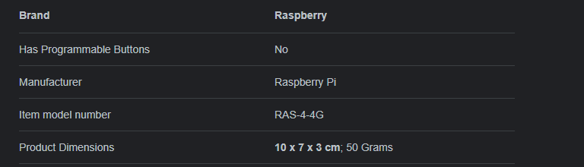

*Figure UM-15 : Raspberry Pi Information*

#2 : Arducam 64MP

The dimensions for Arducam are 25mmX24mm. All the information for this particular component can be found in the image below:

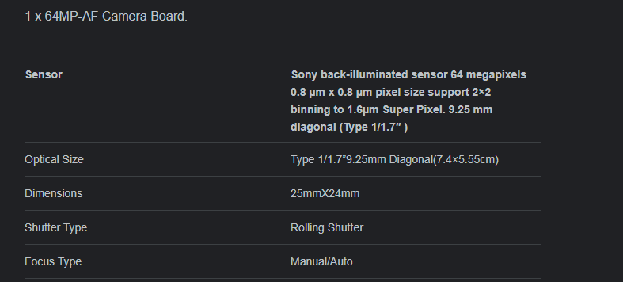

*Figure UM-16 : Arducam 64MP Information*

#4 : Fafeicy Single Phase, DC-AC Solid-State Relay

The dimensions of the DC-AC Solid-State Relay are 8x6x7cm. It weighs 100 grams. All other information on this component of IntersectionSafe can be found in the image below:

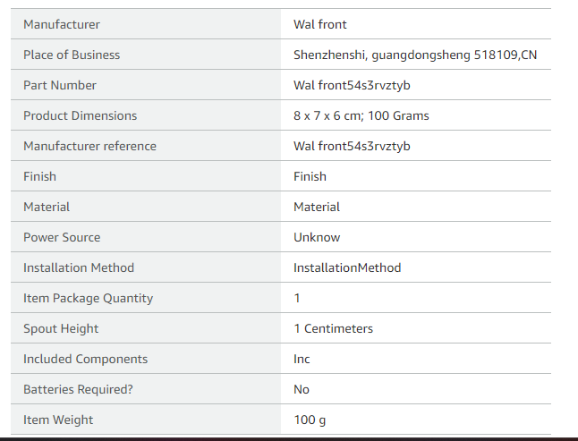

*Figure UM-17 : DC-AC Solid-State Relay Information*

#5 : MEAN WELL RS-15-5 AC to DC Power Supply Single Output

The dimensions of our AC to DC power supply single output is 6.2x5.1x2.8 cm. It weighs 130 grams. All the information for this particular component can be found in the following image:

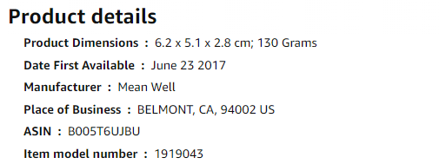

*Figure UM-18 : MEAN WELL RS-15-5 AC to DC Power Supply Single Output Information*

For any other inquiries towards the IntersectionSafe device, its functionalities, utilities and properties, contact us at IntersectionSafe inc.